Case Report

National Gallery DC

### Tracy’s iPhone [2012-07-15-National-Gallery]

# Table of Contents

[Case Report](https://docs.google.com/document/d/1H528_nPqhfp_eOCzvyviwx5U3M1NiPTGtIFaoQoANbY/edit#heading=h.8mjg1w2w81ai)

National Gallery DC

Tracy’s iPhone [2012-07-15-National-Gallery]

Table of Contents

Executive Summary

Equipment and Tools

Details of Tracy’s iPhone

Evidence to Establish Personas

Evidence relating to theft of valuable stamps

Evidence relating to defacement of museum art

Plot Timeline

Conclusion

Appendix A: Correspondence Evidence

Appendix B: WiFi and GPS Location Information

# Executive Summary

On January 21, 2016, Digitech Inc. was called in to assist the National Gallery, Washington D.C. (NGDC) case involving the conspiracy associated with the theft of valuable stamps and defacing of museums are at the NGDC.

* Tracy is a suspect in the aforementioned conspiracy.
* As part of the investigation, Tracy’s iPhone was taken into custody.
* Digitech, Inc. was tasked with investigating evidence relevant to the aforementioned conspiracy.
* Tracy’s motivation for the stamp heist was primarily for financial gain.
* Tracy helped Carry sneak a tablet into the National Gallery.

As described fully in the report, Digitech, Inc. made the following findings.

* Tracy was operating under the alias, Coral.
* Pat was operating under the alias, Perry.
* Email correspondence between Pat and Tracy are evidence that they both were conjuring a plan to steal the stamps.
* There is also evidence that Carry helped Tracy smuggle a tablet into the museum to create an alternate channel of communication around the heist.

### Equipment and Tools

The forensics team used a myriad of solutions to present the evidence in this report including: Autopsy Sleuth Kit, Microsoft Excel, BitRecover, Notepad, GoogleMaps, GrooveMusic, Mozilla Mail, Microsoft PDF Printer, Microsoft Word, Google Translate, Kali Linux, Steghide, DB Browser for SQLite, and custom Python code used for extracting, plotting, and documenting location data from image files.

# Details of Tracy’s iPhone

# Case Name: 2012-07-15-National-Gallery Case #: 1EZ215-P

|  |  |  |
| --- | --- | --- |
| **Name** | **Findings** | **Location in iPhone image file** |
| Model | iPhone 3G | Photos Metadata |
| Host Name | Tracy Sumtwelve’s iPhone /logs/lockdownd.log.1 | Tracy Sumtwelve’s iPhone /logs/lockdownd.log.1 |
| OS Version | iPhone OS 4.2.1 (8C148) /mobile/Library/Logs/AppleSupport/general.log | iPhone OS 4.2.1 (8C148) /mobile/Library/Logs/AppleSupport/general.log |
| Install Time | 6/6/2012 19:03:28 | /mobile/Library/Logs/AppleSupport/general.log |
| User Email | tracysumtwelve@gmail.com | vol5/mobile/Library/Mail |
| Phone Number | 703-340-9661 | /logs/lockdown.log.1 |
| Serial Number | 86004482Y7H | /mobile/Library/Logs/AppleSupport/general.log |
| ICCID | 89014103255195342366 | /logs/lockdown.log.1 |
| IMEI | 012021003735398 | /root/Library/Lockdownactivation_records/wildcard_record.plist |
| MD5 Hash | 34c4888f095dc3241330462923f6fea5 | |
| SHA256 Hash | 71aed05a86a753dec4ef4033ed7f52d6577ccb534ca0d1e83ffd27683e621607 | |

# Evidence to Establish Personas

*This section establishes aliases, phone numbers, email addresses associated with each person, and relationships between each individual.*

Tracy:

Phone Number: (703) 340-9961

Personal Email: tracysumtwelve@gmail.com

Work Email: [tracy.sumtwelve@nationalgallerydc.org](mailto:tracy.sumtwelve@nationalgallerydc.org)

Alias name: Coral

Alias email: coralbluetwo@hotmail.com

Relationship: Accused

Evidence: Apple ID for the phone that sent emails from tracysumtwelve@gmail.com match and there was a native mail application on the same device. Tracy also had her work email configured on the same device.

Pat:

Phone Number: 571-308-3236

Email: perrypatsum@yahoo.com / patsumtwelve@gmail.com

Alias name: Perry

Alias email: perrypatsumtwelve@yahoo.com

Relationship: Tracy’s brother

Evidence: The content in a series of email exchanges between tracysumtwelve@gmail.com and patsumtwelve@gmail.com allowed us to claim that Pat is patsumtwelve@gmail.com. Tracy’s iPhone also had Pat’s contact info stored in the Contacts folder.

Terry:

Phone Number: 703-829-6071

Email: tam_502@yahoo.com or gray@cac.washington.edu

Relationship: Tracy’s daughter

Evidence: Terry’s contact info was stored on Tracy’s iPhone.

Joe:

Email: joe.sum.twelve@gmail.com

Relationship: Tracy’s ex-husband

Carry:

Phone Number: 202-725-2124

Email: carrysum2012@yahoo.com

Evidence: Email and phone contact information was stored in Tracy’s phone

Relationship: Carry is working with Tracy.

King:

Email: throne1966@hotmail.com

Evidence: Email discovered in an exchange about tools needed for the heist. Replied back with a .txt attachment (Evidence 1.3 and email exchange #19).

# Evidence relating to the theft of valuable stamps

*This sub-section provides details regarding the evidence found as it relates to the theft of valuable stamps.*

Tracy, being in financial trouble and in the midst of a custody battle and divorce was looking for an opportunity to resolve her problems

* Evidence 2.1 Artifact 1, Email correspondence

Tracy becomes aware a new exhibit with valuable stamps will arrive at the NGDC and plots with her brother to steal the stamps

* Evidence 2.1 Artifact 13, Email correspondence
* Tracy’s iPhone contained multiple images of the stamps. Evidence 1.4
* Email correspondence from Tracy to [coralbluetwo@gmail.com] about the stamp insurance (Evidence 1.1) includes zip files with PDF copies of the insurance documents (Evidence 1.2). One zip was encrypted and the other was not.

Pat contacts King to assist with the heist

* Evidence 2.1 Artifact 20, Email correspondence
* Evidence 1.3 is the attached document sent from King that contains the tools needed to execute the heist.

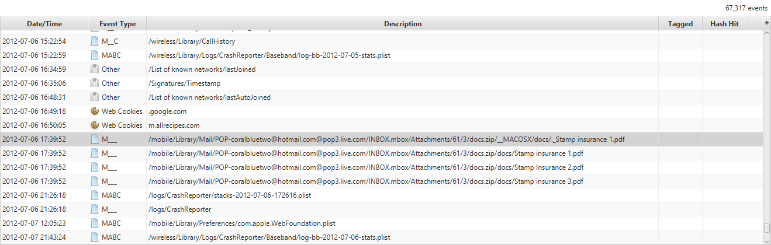

Evidence 1.2 - PDF attachments of stamp insurance policies sent from Tracy to [[coralbluetwo@gmail.com](mailto:coralbluetwo@gmail.com)]

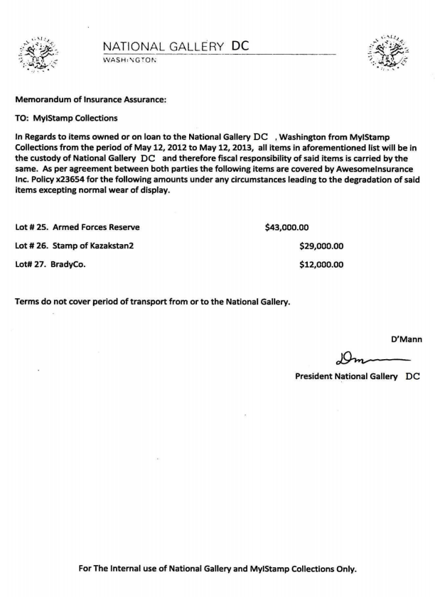

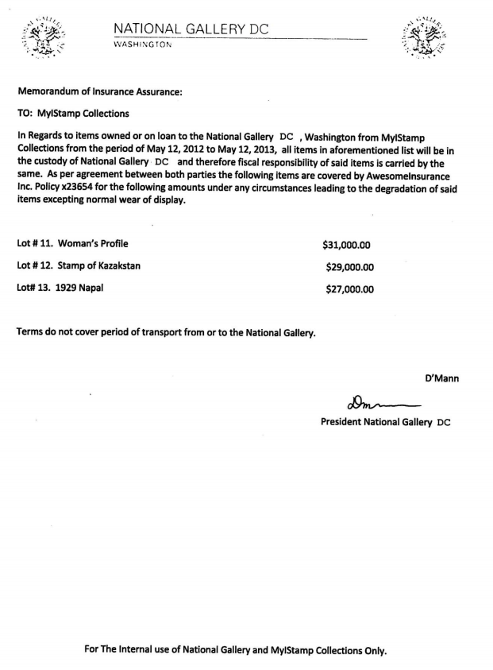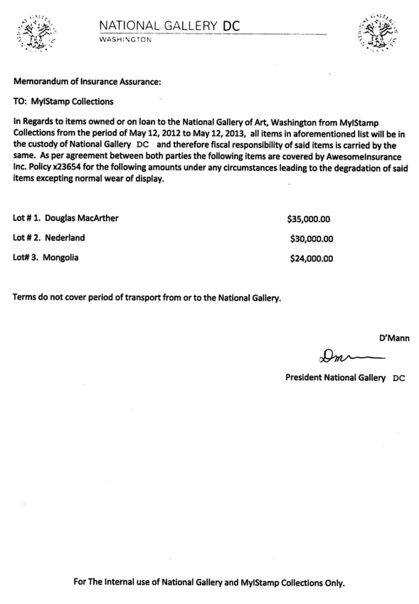

Evidence 1.3

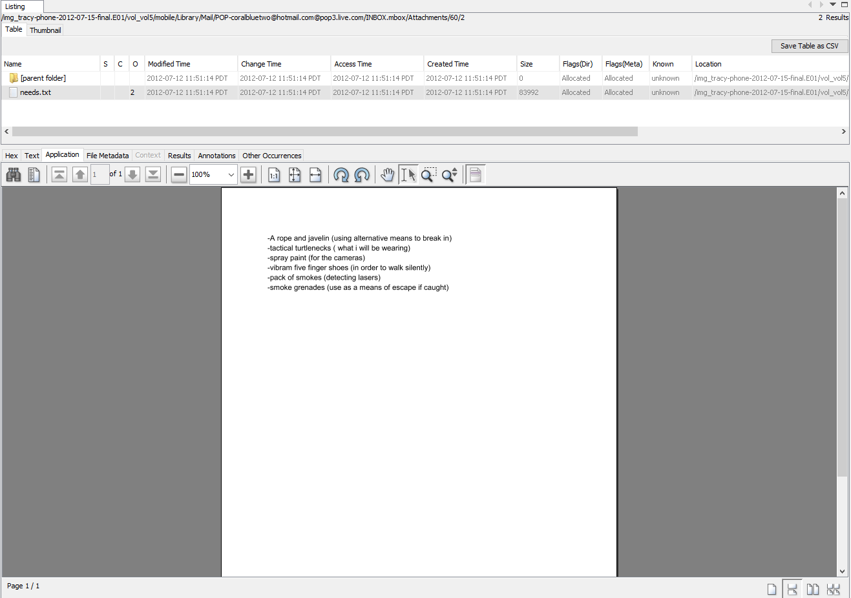

Evidence 1.4 - Stamp images

|  |  |  |
| --- | --- | --- |
|  |  |  |
|  |  |  |
|  |  |  |
|  |  |  |
|  |  |  |
|  |  |  |
|  |  |  |

# Evidence relating to the defacement of museum art

*There was no evidence collected detailing or referencing the defacement of museum art. We suspect that Carries tablet would contain this information.*

# Plot Timeline

* 06/03/2012 - Tracy’s money problems first come to light with her asking her ex-husband for financial help with Terry’s schooling. Joe’s reply is that the only way he will pay for the school is if Terry comes to live with him.
* 06/05/2012 - Carry reaches out to Tracy about T’s financial troubles and invites her to lunch. This is the first of several meetings to develop the plan for the flashmob, theft of the stamps and defacement of the art exhibit.
* 06/06/2012 - We see the first mention of “King” from Pat to Tracy. King will be brought onboard to assist with the theft of the stamps.
* 06/19/2012 - Several communications showing the connection between Pat and Tracy and their respective aliases.
* 06/21-28/2012 - Various email and text communications establishing the existence of the VMs, initial plans to defraud and/or rob the museum for Pat and Tracy’s financial gain.
* 07/03/2012 - Numerous emails detailing the Stamps as the agreed upon target for the theft.
* 07/05/2012 - Tracy and Carry meet for lunch, evidence from emails points to this was the first meeting between the two regarding the flash mob as a cover for the theft.
* 07/09/2012 - Tracy emails the stamp insurance documents to her alias email account
* 07/09-12/2012 - Carry and Tracy's conversations regarding the theft and flash mob accelerate. Carry gets Tracy to help her smuggle her tablet into the museum to take photos, Tracy provides Carry with the security guards schedules.

# Conclusion

Tracy had financial trouble and was struggling with divorce and child custody. She identified an opportunity to resolve her financial strain when she learned of an art exhibit of collectable stamps arriving at the NGDC where she works. She contacted her brother to plan the theft of the stamps and provided the documentation detailing the value of the stamps. Her brother, Pat, contacted King and using blackmail, convinced King to assist them with the theft. King acquiesced and provided Pat with a “needs list” of tools he required to execute the theft.

In parallel with this plot but not necessarily connected, Cary who was aware of Tracy’s financial trouble, contacted Tracy to help her plan a flash mob performance in the NGDC. She also requested Tracy’s assistance with smuggling her tablet into the Gallery and requested a copy of the facility's guard schedule, specifically detailing shift rotations. This evidence points to a need to inspect Carry’s tablet and any other digital items possibly in her possession.

# Appendix A: Correspondence Evidence

This subsection will provide an amalgamation of the email and SMS correspondence evidence.

Evidence 2.1

|  |  |  |  |  |  |  |
| --- | --- | --- | --- | --- | --- | --- |
| **Artifact** | **Sender** | **Recipient** | **Senders Number** | **Date** | **Time** | **Content** |
| 1 | Pat | Tracy | 15713083236 | 6/12/2012 | 9:25 PM | What are you up to this weekend? |
| 2 | Terry | Tracy | 17038296071 | 6/13/2012 | 5:30 PM | I'm going out with dad after school for pizza! Thought I'd let you know if you planned to cook.  T |
| 3 | Tracy | Pat | 15713083236 | 6/13/2012 | 6:30 PM | I don't have any big plans. How about you? |
| 4 | Tracy | Terry | 17038296071 | 6/13/2012 | 6:33 PM | Ok, sounds good. |
| 5 | Tracy | Terry | 17038296071 | 7/3/2012 | 1:41 PM | Hey honey. I'm not sure if we can afford Prufrock anymore... What do you think about maybe switching to someplace else? |
| 6 | Terry | Tracy | 17038296071 | 7/3/2012 | 2:04 PM | moving schools at this point would be the worst! i would rather live with dad and stay at prufrock then change schools :( |
| 7 | Carry | Tracy | 12027252124 | 7/5/2012 | 6:18 PM | Sounds good let's shoot for one àt Bubba s grill |
| 8 | Tracy | Carry | 12027252124 | 7/5/2012 | 6:20 PM | Okay that sounds great. See you there |
| 9 | Tracy | Pat | 15713083236 | 7/6/2012 | 3:03 PM | Hey can you give me a call |
| 10 | Pat | Tracy | 15713083236 | 7/6/2012 | 3:08 PM | Sis I'm really busy can we can do this later |
| 11 | Tracy | Pat | 15713083236 | 7/6/2012 | 3:11 PM | No pat this is important I need you to call me soon |
| 12 | Pat | Tracy | 15713083236 | 7/6/2012 | 3:13 PM | Ok ok I'll call in 5 |
| 13 | Carry | Tracy | 12027252124 | 7/6/2012 | 4:27 PM | I have a table inside |
| 14 | Tracy | Carry | 12027252124 | 7/6/2012 | 4:27 PM | Okay brt |
| 15 | Pat | Tracy | 15713083236 | 7/10/2012 | 3:26 PM | hey sis yo friend coral got a email the attachment needs to be changed to pdf let her know |
| 16 | Tracy | Pat | 15713083236 | 7/10/2012 | 3:58 PM | Sure thing I'll get on it |
| 17 | Tracy | Terry | 17038296071 | 7/10/2012 | 5:18 PM | Going to lunch. You want to go????! |
| 18 | Tracy | Terry | 17038296071 | 7/10/2012 | 6:19 PM | Back at work |
| 19 | Terry | Tracy | 17038296071 | 7/10/2012 | 6:58 PM | I'm busy. Maybe this weekend if dad isn't busy |
| 20 | Carry | Tracy | 12027252124 | 7/11/2012 | 12:41 PM | I'm almost there where should I meet you? |
| 21 | Tracy | Carry | 12027252124 | 7/11/2012 | 12:49 PM | Just meet me out front, I'll take the tablet in. |
| 22 | Tracy | Carry | 12027252124 | 7/12/2012 | 5:06 PM | How's the flashmob going |
| 23 | Terry | Tracy | 17038296071 | 7/13/2012 | 1:02 AM | I really want to go to Dad's this weekend. He said he'll take me shopping for school |

Evidence 2.2

|  |  |  |  |  |
| --- | --- | --- | --- | --- |
| Master Timeline of NGDC Email Correspondence | | | | |
| Artifact # | Timestamp | Header Information | Key Information | Evidence Location |
| 1. | 06/03/2012  06:29:37 | F: joe.sum.twelve@gmail.com  T: tracysumtwelve@gmail.com | Joe (responding to an email from Tracy about Terry’s tuition costs) states that he will not pay for their daughters tuition unless she is living with him. | Protected Index |
| 2. | 06/03/2012  09:34 | F: Tracysumtwelve@gmail.com  T: perrypatsum@yahoo.com | Tracy mentioned that Coral has great news about her job and advises Pat to speak with her. | Protected Index |
| 3. | 06/05/2012  08:51:34 | F: carrysum2012@yahoo.com  T: tracysumtwelve@gmail.com | Carry talks about seeing Tracy’s financial troubles on Facebook and inquires about meeting for lunch on Friday. | Protected Index |
| 4. | 06/06/2012  08:27:52 | F: patsumtwelve@gmail.com  T: tracysumtwelve@gmail.com | Pat informs Tracy that he knows a guy named King, in response to the email from 06/03/2012 09:34 | Protected Index |
| 5. | ?? | F: patsumtwelve@gmail.com  T: tracysumtwelve@gmail.com | Pat has provided, for an additional time, the login info for Tracy’s alias account | Protected Index. |
| 6. | 6/19/2012 20:06:33 | F: patsumtwelve@gmail.com  T: tracysumtwelve@gmail.com | Pat emails Tracy letting her know that he has accepted her proposal and asks her to email using her alias for further instructions. | Protected Index |
| 7. | 6/19/2012  13:26:47 | F: perrypatsum@yahoo.com  T: tracysumtwelve@gmail.com | Perry lets Tracy know that she has been in contact with Tracy’s brother and references the Alias email. | Protected Index |
| 8. | 06/19/2012  13:06:33 | F: patsumtwelve@gmail.com  T: tracysumtwelve@gmail.com | Pat’s email was in French, when translated he indicated he is onboard with Tracy’s plan | Protected Index |
| 9. | 06/19/2012  14:39:34 | F: coralbluetwo@hotmail.com  T: perrypatsum@yahoo.com | Using new alias accounts Tracy responds to her brother Pat that she is now receiving his emails from the new accounts | Protected Index |
| 10. | 06/21/2012  Various | F: coralbluetwo@hotmail.com  T: perrypatsum@yahoo.com | Email exchange acknowledging Tracy’s receipt of the VM setup instructions | Protected Index |
| 11. | 06/28/2012  Various | F: perrypatsum@yahoo.com  T: coralbluetwo@hotmail.com | Conversations about new emails and VM’s being complete and initial plans to come up with fraud/theft ideas for both of their money troubles. | Protected Index |
| 12. | 06/29/2012  07:31:37 | F: perrypatsum@yahoo.com  T: tracysumtwelve@gmail.com | Perry wants to coordinate dinner with Tracy and Coral | Protected Index |
| 13. | 07/03/2012  Various | F: perrypatsum@yahoo.com  T: tracysumtwelve@gmail.com | Various back and forth identifying “valuable stamps” as final target | Protected Index |
| 14. | 07/06/2012 | F: tracysumtwelve@gmail.com  T: carrysum2012@yahoo.com | Tracy thanks Carry for lunch | Protected Index |
| 15. | 07/09/2012 | F: carrysumtwelve@gmail.com  T: tarysumtwelve@gmail.com | Carry is enquiring if Tracy can help her get her tablet into the museum past security to take pictures for the flash mob | Protected Index |
| 16. | 07/09/2012  07:44 | F: tracysumtwelve@gmail.com  T: coralbluetwo@hotmail.com | Tracy emails the Stamp insurance documents to her alias email address | Protected Index |
| 17. | 07/10/2012  08:24 | F: [patsumtwelve@gmail.com](mailto:patsumtwelve@gmail.com)  T: coralbluetwo@hotmail.com | Pat forwards coral an email from King detailing the blackmail against King and an attached txt file detailing Kings needs for the theft. | Inbox |
| 18. | 07/09/2012 | F: payday magic  T: tracysumtwelve@gmail.com | Payday loan application for $900 by Tracy | Protected Index |
| 19. | 07/10/2012  Various | F: tracysumtwelve@gmail.com  T: carrysum2012@gmail.com | Tracy says she can help and Carry asks if she can arrive on the 11th around 9am. | Protected Index |
| 20. | 07/10/2012  11:19am | F:patsumtwelve@gmail.com  T: coralbluetwo@hotmail.com | Pat forwards Coral’s email from King detailing King's supplies needed for robbery and Pat’s blackmailing of King. | Protected Index |
| 21. | ?? | F: carrysum2012@yahoo.com  T: tracysumtwelve@gmail.com | Carry is inquiring about shift changes for the guards for the event day | Protected Index |
| 22. | 07/12/2012 | F: Tracysumtwelve@gmail.com  T: carysum2012@yahoo.com | Tracy sends Carry the security guard schedule. | Protected index |

# Appendix B: WiFi and GPS Location Information

Evidence 3.1 Wifi Locations (Marker numbers correspond to artifact number)

/vol5/root/Library/Caches/locationd/consolidated.db

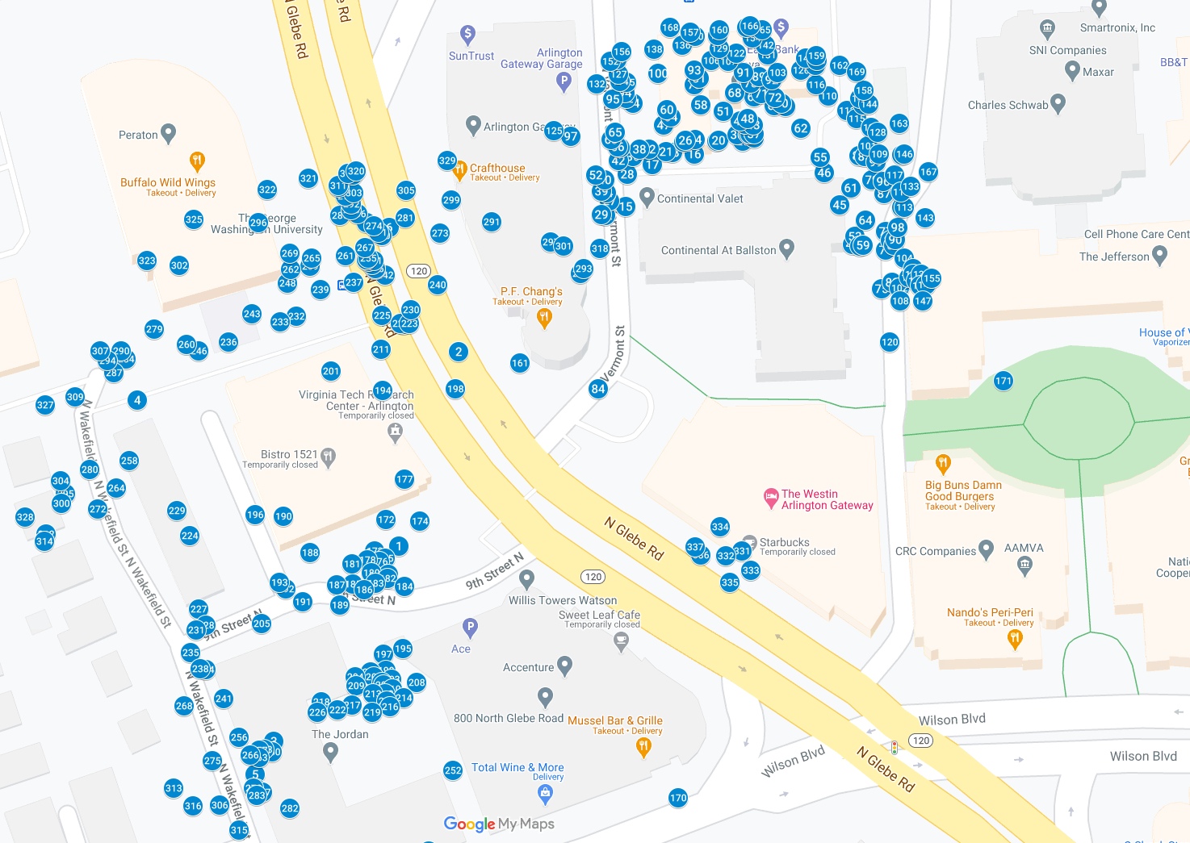

|  |  |  |  |  |
| --- | --- | --- | --- | --- |
| Location Information | | | | |
| Artifact | Timestamp | Header Information | Body | Screenshot |
| 1 | 6/13/12 7:01:22.474 PM | 44:1e:a1:f4:d:7f | 38.88055896, -77.11553561 | <http://maps.google.com/maps?q=38.88055896,-77.11553561> |
| 2 | 6/13/12 7:01:22.474 PM | 0:23:5e:b0:6d:f1 | 38.88106083, -77.11533838 | <http://maps.google.com/maps?q=38.88106083,-77.11533838> |
| 3 | 6/13/12 7:01:22.474 PM | 0:26:b8:ac:1c:10 | 38.88005346, -77.11595332 | <http://maps.google.com/maps?q=38.88005346,-77.11595332> |
| 4 | 6/13/12 7:01:22.474 PM | c0:c1:c0:15:66:fa | 38.88093715, -77.11640596 | <http://maps.google.com/maps?q=38.88093715,-77.11640596> |
| 5 | 6/13/12 7:01:22.474 PM | e0:46:9a:3f:1b:a6 | 38.87996816, -77.11601394 | <http://maps.google.com/maps?q=38.87996816,-77.11601394> |
| 6 | 6/13/12 7:01:22.474 PM | 54:75:d0:a5:f:a3 | 38.88138395, -77.11556851 | <http://maps.google.com/maps?q=38.88138395,-77.11556851> |
| 7 | 6/13/12 7:01:22.474 PM | 54:75:d0:a5:f:a0 | 38.88139647, -77.11564362 | <http://maps.google.com/maps?q=38.88139647,-77.11564362> |
| 8 | 6/13/12 7:01:22.474 PM | 0:26:b8:ad:bd:dc | 38.87974703, -77.11598318 | <http://maps.google.com/maps?q=38.87974703,-77.11598318> |
| 9 | 6/13/12 7:01:22.474 PM | 0:26:b8:ac:19:d0 | 38.87969022, -77.1154859 | <http://maps.google.com/maps?q=38.87969022,-77.1154859> |
| 10 | 6/13/12 7:01:22.474 PM | 0:26:f3:f8:b8:fb | 38.87970983, -77.11530274 | <http://maps.google.com/maps?q=38.87970983,-77.11530274> |
| 11 | 6/13/12 7:01:22.474 PM | 0:26:f3:f8:b8:f8 | 38.87970793, -77.11529815 | <http://maps.google.com/maps?q=38.87970793,-77.11529815> |
| 12 | 6/13/12 7:01:22.474 PM | 0:26:b8:ae:e7:1b | 38.8796842, -77.11539471 | <http://maps.google.com/maps?q=38.8796842,-77.11539471> |
| 13 | 6/13/12 7:01:22.474 PM | 0:26:f3:f8:b8:f9 | 38.87969332, -77.11530435 | <http://maps.google.com/maps?q=38.87969332,-77.11530435> |
| 14 | 6/13/12 7:01:22.474 PM | 0:26:b8:ac:6:68 | 38.87969988, -77.11591041 | <http://maps.google.com/maps?q=38.87969988,-77.11591041> |
| 15 | 6/13/12 7:04:03.744 PM | e4:e0:c5:f:29:fa | 38.88143724, -77.11478394 | <http://maps.google.com/maps?q=38.88143724,-77.11478394> |
| 16 | 6/13/12 7:04:03.744 PM | 0:18:1:fb:b2:c3 | 38.8815732, -77.11455619 | <http://maps.google.com/maps?q=38.8815732,-77.11455619> |
| 17 | 6/13/12 7:04:03.744 PM | 0:18:f8:1a:69:23 | 38.88154673, -77.11469429 | <http://maps.google.com/maps?q=38.88154673,-77.11469429> |
| 18 | 6/13/12 7:04:03.744 PM | 0:26:62:44:d5:4f | 38.88157737, -77.11462634 | <http://maps.google.com/maps?q=38.88157737,-77.11462634> |
| 19 | 6/13/12 7:04:03.744 PM | c4:17:fe:0:65:d | 38.88160669, -77.11448079 | <http://maps.google.com/maps?q=38.88160669,-77.11448079> |
| 20 | 6/13/12 7:04:03.744 PM | 78:cd:8e:c:99:88 | 38.88160783, -77.11447507 | <http://maps.google.com/maps?q=38.88160783,-77.11447507> |
| 21 | 6/13/12 7:04:03.744 PM | 0:23:97:eb:e8:d7 | 38.88157981, -77.11465042 | <http://maps.google.com/maps?q=38.88157981,-77.11465042> |
| 22 | 6/13/12 7:04:03.744 PM | 10:9a:dd:83:92:13 | 38.88141357, -77.11484962 | <http://maps.google.com/maps?q=38.88141357,-77.11484962> |
| 23 | 6/13/12 7:04:03.744 PM | 0:7f:28:1c:b4:20 | 38.88160395, -77.11459022 | <http://maps.google.com/maps?q=38.88160395,-77.11459022> |
| 24 | 6/13/12 7:04:03.744 PM | 0:25:9c:e4:f9:55 | 38.88161092, -77.11455142 | <http://maps.google.com/maps?q=38.88161092,-77.11455142> |
| 25 | 6/13/12 7:04:03.744 PM | 78:cd:8e:c:99:8a | 38.88160616, -77.11439394 | <http://maps.google.com/maps?q=38.88160616,-77.11439394> |
| 26 | 6/13/12 7:04:03.744 PM | 0:1f:90:dc:aa:dc | 38.8816086, -77.11458355 | <http://maps.google.com/maps?q=38.8816086,-77.11458355> |
| 27 | 6/13/12 7:04:03.744 PM | 0:18:f8:1b:16:d3 | 38.88145112, -77.11483669 | <http://maps.google.com/maps?q=38.88145112,-77.11483669> |
| 28 | 6/13/12 7:04:03.744 PM | 0:1f:90:e8:ff:42 | 38.88152045, -77.11477804 | <http://maps.google.com/maps?q=38.88152045,-77.11477804> |
| 29 | 6/13/12 7:04:03.744 PM | 10:9a:dd:86:b6:f1 | 38.88141649, -77.1148625 | <http://maps.google.com/maps?q=38.88141649,-77.1148625> |
| 30 | 6/13/12 7:04:03.744 PM | 0:26:62:b5:3e:f4 | 38.88162308, -77.11441218 | <http://maps.google.com/maps?q=38.88162308,-77.11441218> |
| 31 | 6/13/12 7:04:03.744 PM | 0:23:33:16:af:a0 | 38.8816142, -77.11435759 | <http://maps.google.com/maps?q=38.8816142,-77.11435759> |
| 32 | 6/13/12 7:04:03.744 PM | 0:1f:90:b4:69:f8 | 38.88158559, -77.11470586 | <http://maps.google.com/maps?q=38.88158559,-77.11470586> |
| 33 | 6/13/12 7:04:03.744 PM | 78:cd:8e:c:99:8b | 38.88162446, -77.11437678 | <http://maps.google.com/maps?q=38.88162446,-77.11437678> |
| 34 | 6/13/12 7:04:03.744 PM | 0:22:75:ef:19:5f | 38.88147187, -77.11484867 | <http://maps.google.com/maps?q=38.88147187,-77.11484867> |
| 35 | 6/13/12 7:04:03.744 PM | 0:26:b8:3b:63:48 | 38.88162553, -77.11436891 | <http://maps.google.com/maps?q=38.88162553,-77.11436891> |
| 36 | 6/13/12 7:04:03.744 PM | 70:73:cb:b5:7b:df | 38.88156569, -77.11475777 | <http://maps.google.com/maps?q=38.88156569,-77.11475777> |
| 37 | 6/13/12 7:04:03.744 PM | 0:26:b8:17:a6:ae | 38.88162535, -77.11435669 | <http://maps.google.com/maps?q=38.88162535,-77.11435669> |
| 38 | 6/13/12 7:04:03.744 PM | 0:1e:4a:e5:17:23 | 38.88158553, -77.11473774 | <http://maps.google.com/maps?q=38.88158553,-77.11473774> |
| 39 | 6/13/12 7:04:03.744 PM | c8:4c:75:40:9e:49 | 38.88147741, -77.11486297 | <http://maps.google.com/maps?q=38.88147741,-77.11486297> |
| 40 | 6/13/12 7:04:03.744 PM | 0:22:6b:64:bb:8e | 38.88150566, -77.11485427 | <http://maps.google.com/maps?q=38.88150566,-77.11485427> |
| 41 | 6/13/12 7:04:03.744 PM | 0:1f:90:d7:77:c0 | 38.8816508, -77.1143859 | <http://maps.google.com/maps?q=38.8816508,-77.1143859> |
| 42 | 6/13/12 7:04:03.744 PM | 0:22:75:24:52:cc | 38.88155686, -77.11480695 | <http://maps.google.com/maps?q=38.88155686,-77.11480695> |
| 43 | 6/13/12 7:04:03.744 PM | c4:3d:c7:ae:38:66 | 38.88164722, -77.11435991 | <http://maps.google.com/maps?q=38.88164722,-77.11435991> |
| 44 | 6/13/12 7:04:03.744 PM | 78:cd:8e:c:99:89 | 38.88165903, -77.1144014 | <http://maps.google.com/maps?q=38.88165903,-77.1144014> |
| 45 | 6/13/12 7:04:03.744 PM | 0:1f:90:ed:3c:2e | 38.88144159, -77.1140722 | <http://maps.google.com/maps?q=38.88144159,-77.1140722> |
| 46 | 6/13/12 7:04:03.744 PM | 84:db:2f:3:1c:64 | 38.88152474, -77.11412346 | <http://maps.google.com/maps?q=38.88152474,-77.11412346> |
| 47 | 6/13/12 7:04:03.744 PM | 0:17:3f:83:cb:82 | 38.8816471, -77.11465734 | <http://maps.google.com/maps?q=38.8816471,-77.11465734> |
| 48 | 6/13/12 7:04:03.744 PM | 0:26:62:e3:60:10 | 38.88166379, -77.11437833 | <http://maps.google.com/maps?q=38.88166379,-77.11437833> |
| 49 | 6/13/12 7:04:03.744 PM | 0:1f:90:fb:9a:d0 | 38.88134002, -77.11402976 | <http://maps.google.com/maps?q=38.88134002,-77.11402976> |
| 50 | 6/13/12 7:04:03.744 PM | 0:1e:4a:e5:17:24 | 38.88158988, -77.11480194 | <http://maps.google.com/maps?q=38.88158988,-77.11480194> |
| 51 | 6/13/12 7:04:03.744 PM | 90:27:e4:5c:d1:8b | 38.88168364, -77.11445981 | <http://maps.google.com/maps?q=38.88168364,-77.11445981> |
| 52 | 6/13/12 7:04:03.744 PM | 0:18:18:ff:7d:8b | 38.88151955, -77.11488258 | <http://maps.google.com/maps?q=38.88151955,-77.11488258> |
| 53 | 6/13/12 7:04:03.744 PM | e0:91:f5:ec:6c:23 | 38.88135969, -77.11402219 | <http://maps.google.com/maps?q=38.88135969,-77.11402219> |
| 54 | 6/13/12 7:04:03.744 PM | 0:26:b8:af:de:1d | 38.88166946, -77.11463308 | <http://maps.google.com/maps?q=38.88166946,-77.11463308> |
| 55 | 6/13/12 7:04:03.744 PM | 84:db:2f:3:23:49 | 38.88156437, -77.11413609 | <http://maps.google.com/maps?q=38.88156437,-77.11413609> |
| 56 | 6/13/12 7:04:03.744 PM | 0:1e:4a:e5:17:20 | 38.88159155, -77.11481052 | <http://maps.google.com/maps?q=38.88159155,-77.11481052> |
| 57 | 6/13/12 7:04:03.744 PM | 68:7f:74:94:aa:ec | 38.88133502, -77.11400651 | <http://maps.google.com/maps?q=38.88133502,-77.11400651> |
| 58 | 6/13/12 7:04:03.744 PM | 0:7f:28:a:c5:c4 | 38.88169968, -77.11453354 | <http://maps.google.com/maps?q=38.88169968,-77.11453354> |
| 59 | 6/13/12 7:04:03.744 PM | 68:7f:74:94:aa:ed | 38.88133615, -77.11399537 | <http://maps.google.com/maps?q=38.88133615,-77.11399537> |
| 60 | 6/13/12 7:04:03.744 PM | 0:1f:90:e9:76:b | 38.88168793, -77.11464738 | <http://maps.google.com/maps?q=38.88168793,-77.11464738> |
| 61 | 6/13/12 7:04:03.744 PM | 0:26:62:b7:3e:e | 38.88148528, -77.11403554 | <http://maps.google.com/maps?q=38.88148528,-77.11403554> |
| 62 | 6/13/12 7:04:03.744 PM | 0:26:b8:5e:fc:72 | 38.88164049, -77.11420023 | <http://maps.google.com/maps?q=38.88164049,-77.11420023> |
| 63 | 6/13/12 7:04:03.744 PM | 0:26:b8:5e:81:e4 | 38.88161075, -77.11483067 | <http://maps.google.com/maps?q=38.88161075,-77.11483067> |
| 64 | 6/13/12 7:04:03.744 PM | 0:7f:28:2b:b6:95 | 38.88140171, -77.1139853 | <http://maps.google.com/maps?q=38.88140171,-77.1139853> |
| 65 | 6/13/12 7:04:03.744 PM | 0:1f:90:f0:54:da | 38.88163012, -77.11481797 | <http://maps.google.com/maps?q=38.88163012,-77.11481797> |
| 66 | 6/13/12 7:04:03.744 PM | 0:26:b8:af:1b:c5 | 38.88169914, -77.11429029 | <http://maps.google.com/maps?q=38.88169914,-77.11429029> |
| 67 | 6/13/12 7:04:03.744 PM | 88:43:e1:d7:84:50 | 38.88172066, -77.11435794 | <http://maps.google.com/maps?q=38.88172066,-77.11435794> |
| 68 | 6/13/12 7:04:03.744 PM | 0:1f:90:eb:8c:3b | 38.88173264, -77.11441981 | <http://maps.google.com/maps?q=38.88173264,-77.11441981> |
| 69 | 6/13/12 7:04:03.744 PM | 0:26:62:ce:5c:ea | 38.88169705, -77.11425167 | <http://maps.google.com/maps?q=38.88169705,-77.11425167> |
| 70 | 6/13/12 7:04:03.744 PM | 0:1f:f3:f4:91:bb | 38.88170504, -77.11426556 | <http://maps.google.com/maps?q=38.88170504,-77.11426556> |
| 71 | 6/13/12 7:04:03.744 PM | 0:18:1:f5:30:ba | 38.88172852, -77.1143319 | <http://maps.google.com/maps?q=38.88172852,-77.1143319> |
| 72 | 6/13/12 7:04:03.744 PM | 0:7f:28:11:90:c6 | 38.88171833, -77.11428588 | <http://maps.google.com/maps?q=38.88171833,-77.11428588> |
| 73 | 6/13/12 7:04:03.744 PM | 0:7f:28:2a:69:27 | 38.88175261, -77.11455583 | <http://maps.google.com/maps?q=38.88175261,-77.11455583> |
| 74 | 6/13/12 7:04:03.744 PM | 0:22:75:4c:57:79 | 38.88170462, -77.11475878 | <http://maps.google.com/maps?q=38.88170462,-77.11475878> |
| 75 | 6/13/12 7:04:03.744 PM | 0:90:4b:75:ec:4b | 38.88122379, -77.11393213 | <http://maps.google.com/maps?q=38.88122379,-77.11393213> |
| 76 | 6/13/12 7:04:03.744 PM | 0:26:b8:33:86:18 | 38.88132381, -77.11391836 | <http://maps.google.com/maps?q=38.88132381,-77.11391836> |
| 77 | 6/13/12 7:04:03.744 PM | 0:1f:90:cb:cb:e8 | 38.88137209, -77.11391937 | <http://maps.google.com/maps?q=38.88137209,-77.11391937> |
| 78 | 6/13/12 7:04:03.744 PM | d8:30:62:33:5:33 | 38.88175648, -77.11436641 | <http://maps.google.com/maps?q=38.88175648,-77.11436641> |
| 79 | 6/13/12 7:04:03.744 PM | 0:26:62:a1:8f:e4 | 38.88150703, -77.11396539 | <http://maps.google.com/maps?q=38.88150703,-77.11396539> |
| 80 | 6/13/12 7:04:03.744 PM | 0:1f:90:dc:66:18 | 38.88156968, -77.11400794 | <http://maps.google.com/maps?q=38.88156968,-77.11400794> |
| 81 | 6/13/12 7:04:03.744 PM | 0:1f:90:e8:ff:4c | 38.88176977, -77.11453813 | <http://maps.google.com/maps?q=38.88176977,-77.11453813> |
| 82 | 6/13/12 7:04:03.744 PM | 0:26:62:dc:63:b8 | 38.88171607, -77.11478084 | <http://maps.google.com/maps?q=38.88171607,-77.11478084> |
| 83 | 6/13/12 7:04:03.744 PM | 68:7f:74:66:2c:f6 | 38.88134866, -77.11390244 | <http://maps.google.com/maps?q=38.88134866,-77.11390244> |
| 84 | 6/13/12 7:04:03.744 PM | 0:1f:90:fa:40:3c | 38.88096624, -77.11487352 | <http://maps.google.com/maps?q=38.88096624,-77.11487352> |
| 85 | 6/13/12 7:04:03.744 PM | 0:1f:90:f0:5b:e7 | 38.88156688, -77.11398798 | <http://maps.google.com/maps?q=38.88156688,-77.11398798> |
| 86 | 6/13/12 7:04:03.744 PM | e0:46:9a:3c:a3:a4 | 38.8813371, -77.11389219 | <http://maps.google.com/maps?q=38.8813371,-77.11389219> |
| 87 | 6/13/12 7:04:03.744 PM | 68:7f:74:78:ec:fa | 38.88147109, -77.11392492 | <http://maps.google.com/maps?q=38.88147109,-77.11392492> |
| 88 | 6/13/12 7:04:03.744 PM | 0:7f:28:32:2f:42 | 38.88123995, -77.11389786 | <http://maps.google.com/maps?q=38.88123995,-77.11389786> |
| 89 | 6/13/12 7:04:03.744 PM | 0:1f:90:be:1:f8 | 38.88177251, -77.11434 | <http://maps.google.com/maps?q=38.88177251,-77.11434> |
| 90 | 6/13/12 7:04:03.744 PM | 0:1f:90:e1:c9:f2 | 38.88135164, -77.11388808 | <http://maps.google.com/maps?q=38.88135164,-77.11388808> |
| 91 | 6/13/12 7:04:03.744 PM | 0:1f:f3:f4:d3:b9 | 38.88178312, -77.11439216 | <http://maps.google.com/maps?q=38.88178312,-77.11439216> |
| 92 | 6/13/12 7:04:03.744 PM | 0:1f:90:e0:4e:1e | 38.8817653, -77.11429858 | <http://maps.google.com/maps?q=38.8817653,-77.11429858> |
| 93 | 6/13/12 7:04:03.744 PM | 0:26:62:ce:4f:2b | 38.88178908, -77.11455655 | <http://maps.google.com/maps?q=38.88178908,-77.11455655> |
| 94 | 6/13/12 7:04:03.744 PM | 0:26:62:e2:3:14 | 38.88173216, -77.11478519 | <http://maps.google.com/maps?q=38.88173216,-77.11478519> |
| 95 | 6/13/12 7:04:03.744 PM | 90:84:d:ee:50:29 | 38.8817141, -77.11482745 | <http://maps.google.com/maps?q=38.8817141,-77.11482745> |
| 96 | 6/13/12 7:04:03.744 PM | 0:1f:90:e4:80:5 | 38.88150262, -77.11392742 | <http://maps.google.com/maps?q=38.88150262,-77.11392742> |
| 97 | 6/13/12 7:04:03.744 PM | 94:44:52:69:e4:eb | 38.88161849, -77.11496579 | <http://maps.google.com/maps?q=38.88161849,-77.11496579> |
| 98 | 6/13/12 7:04:03.744 PM | 0:19:e3:fa:ba:94 | 38.8813827, -77.11388021 | <http://maps.google.com/maps?q=38.8813827,-77.11388021> |
| 99 | 6/13/12 7:04:03.744 PM | 0:26:62:ca:5d:7b | 38.88155156, -77.11395156 | <http://maps.google.com/maps?q=38.88155156,-77.11395156> |
| 100 | 6/13/12 7:04:03.744 PM | 0:26:62:e1:7b:fc | 38.88178151, -77.11467546 | <http://maps.google.com/maps?q=38.88178151,-77.11467546> |
| 101 | 6/13/12 7:04:03.744 PM | 0:26:62:72:49:d9 | 38.88159388, -77.11397725 | <http://maps.google.com/maps?q=38.88159388,-77.11397725> |
| 102 | 6/13/12 7:04:03.744 PM | 74:44:1:45:9c:e4 | 38.88122731, -77.11387401 | <http://maps.google.com/maps?q=38.88122731,-77.11387401> |
| 103 | 6/13/12 7:04:03.744 PM | 0:14:bf:2a:a2:b9 | 38.88178282, -77.11427974 | <http://maps.google.com/maps?q=38.88178282,-77.11427974> |
| 104 | 6/13/12 7:04:03.744 PM | 98:fc:11:94:68:7d | 38.88130271, -77.11385822 | <http://maps.google.com/maps?q=38.88130271,-77.11385822> |
| 105 | 6/13/12 7:04:03.744 PM | 0:1a:70:78:f7:49 | 38.88175958, -77.11477959 | <http://maps.google.com/maps?q=38.88175958,-77.11477959> |
| 106 | 6/13/12 7:04:03.744 PM | 0:1f:33:df:90:52 | 38.88181424, -77.11449939 | <http://maps.google.com/maps?q=38.88181424,-77.11449939> |
| 107 | 6/13/12 7:04:03.744 PM | 0:15:ff:15:a2:1e | 38.88181304, -77.11444294 | <http://maps.google.com/maps?q=38.88181304,-77.11444294> |
| 108 | 6/13/12 7:04:03.744 PM | 0:7f:28:30:3:2b | 38.88119298, -77.11387157 | <http://maps.google.com/maps?q=38.88119298,-77.11387157> |
| 109 | 6/13/12 7:04:03.744 PM | 0:1e:e5:62:96:e2 | 38.88157325, -77.11394077 | <http://maps.google.com/maps?q=38.88157325,-77.11394077> |
| 110 | 6/13/12 7:04:03.744 PM | 0:23:69:54:38:4b | 38.88172227, -77.11411029 | <http://maps.google.com/maps?q=38.88172227,-77.11411029> |
| 111 | 6/13/12 7:04:03.744 PM | 0:1f:90:d0:65:0 | 38.8814342, -77.1138646 | <http://maps.google.com/maps?q=38.8814342,-77.1138646> |
| 112 | 6/13/12 7:04:03.744 PM | 0:7f:28:b9:6d:27 | 38.88168627, -77.11404871 | <http://maps.google.com/maps?q=38.88168627,-77.11404871> |
| 113 | 6/13/12 7:04:03.744 PM | 0:21:0:69:a3:6c | 38.88143491, -77.11385905 | <http://maps.google.com/maps?q=38.88143491,-77.11385905> |
| 114 | 6/13/12 7:04:03.744 PM | 0:26:62:ce:4e:38 | 38.88176161, -77.11480307 | <http://maps.google.com/maps?q=38.88176161,-77.11480307> |
| 115 | 6/13/12 7:04:03.744 PM | c:85:25:c7:b6:d0 | 38.88166457, -77.11401653 | <http://maps.google.com/maps?q=38.88166457,-77.11401653> |
| 116 | 6/13/12 7:04:03.744 PM | c0:c1:c0:1b:ff:e5 | 38.88175243, -77.11414945 | <http://maps.google.com/maps?q=38.88175243,-77.11414945> |
| 117 | 6/13/12 7:04:03.744 PM | d0:df:c7:c6:51:e8 | 38.88151884, -77.11389046 | <http://maps.google.com/maps?q=38.88151884,-77.11389046> |
| 118 | 6/13/12 7:04:03.744 PM | 0:1f:90:f5:d3:fc | 38.88147419, -77.11386793 | <http://maps.google.com/maps?q=38.88147419,-77.11386793> |
| 119 | 6/13/12 7:04:03.744 PM | 0:26:b8:17:4e:43 | 38.88125324, -77.11384046 | <http://maps.google.com/maps?q=38.88125324,-77.11384046> |
| 120 | 6/13/12 7:04:03.744 PM | 0:26:b8:44:88:5f | 38.88108551, -77.11390584 | <http://maps.google.com/maps?q=38.88108551,-77.11390584> |
| 121 | 6/13/12 7:04:03.744 PM | 0:26:62:61:5a:a9 | 38.88127672, -77.11382895 | <http://maps.google.com/maps?q=38.88127672,-77.11382895> |
| 122 | 6/13/12 7:04:03.744 PM | 30:46:9a:95:d5:ca | 38.88183361, -77.11441653 | <http://maps.google.com/maps?q=38.88183361,-77.11441653> |
| 123 | 6/13/12 7:04:03.744 PM | 0:25:9c:32:5:2c | 38.88126099, -77.11382877 | <http://maps.google.com/maps?q=38.88126099,-77.11382877> |
| 124 | 6/13/12 7:04:03.744 PM | 0:1f:90:c5:80:9c | 38.88164103, -77.11396831 | <http://maps.google.com/maps?q=38.88164103,-77.11396831> |
| 125 | 6/13/12 7:04:03.744 PM | 0:15:62:ff:e0:db | 38.88163256, -77.11502194 | <http://maps.google.com/maps?q=38.88163256,-77.11502194> |
| 126 | 6/13/12 7:04:03.744 PM | 0:1f:90:ce:7a:1c | 38.8817898, -77.11420184 | <http://maps.google.com/maps?q=38.8817898,-77.11420184> |
| 127 | 6/13/12 7:04:03.744 PM | 0:26:b8:31:2e:3 | 38.8817805, -77.11480861 | <http://maps.google.com/maps?q=38.8817805,-77.11480861> |
| 128 | 6/13/12 7:04:03.744 PM | 0:1f:90:fe:d8:40 | 38.88163006, -77.11394703 | <http://maps.google.com/maps?q=38.88163006,-77.11394703> |
| 129 | 6/13/12 7:04:03.744 PM | 0:26:b8:98:7a:42 | 38.88184547, -77.11447155 | <http://maps.google.com/maps?q=38.88184547,-77.11447155> |
| 130 | 6/13/12 7:04:03.744 PM | 0:1f:90:f7:5a:14 | 38.88124471, -77.11381757 | <http://maps.google.com/maps?q=38.88124471,-77.11381757> |
| 131 | 6/13/12 7:04:03.744 PM | 0:1f:90:e0:4f:e3 | 38.88182967, -77.11431092 | <http://maps.google.com/maps?q=38.88182967,-77.11431092> |
| 132 | 6/13/12 7:04:03.744 PM | 0:18:39:46:d0:ba | 38.88175499, -77.1148808 | <http://maps.google.com/maps?q=38.88175499,-77.1148808> |
| 133 | 6/13/12 7:04:03.744 PM | 0:26:62:df:df:51 | 38.88148957, -77.11383688 | <http://maps.google.com/maps?q=38.88148957,-77.11383688> |
| 134 | 6/13/12 7:04:03.744 PM | 0:26:62:9f:6e:71 | 38.88126087, -77.11380231 | <http://maps.google.com/maps?q=38.88126087,-77.11380231> |
| 135 | 6/13/12 7:04:03.744 PM | 0:1e:8c:62:1:e4 | 38.88123255, -77.11380374 | <http://maps.google.com/maps?q=38.88123255,-77.11380374> |
| 136 | 6/13/12 7:04:03.744 PM | 0:26:62:86:25:dc | 38.88185477, -77.11459583 | <http://maps.google.com/maps?q=38.88185477,-77.11459583> |
| 137 | 6/13/12 7:04:03.744 PM | c:85:25:c7:b6:d2 | 38.88170075, -77.11399596 | <http://maps.google.com/maps?q=38.88170075,-77.11399596> |
| 138 | 6/13/12 7:04:03.744 PM | 0:26:62:f1:92:cc | 38.88184446, -77.11469066 | <http://maps.google.com/maps?q=38.88184446,-77.11469066> |
| 139 | 6/13/12 7:04:03.744 PM | 30:46:9a:95:c1:f0 | 38.88157057, -77.11386483 | <http://maps.google.com/maps?q=38.88157057,-77.11386483> |
| 140 | 6/13/12 7:04:03.744 PM | c:85:25:c7:b6:d1 | 38.88171738, -77.11400479 | <http://maps.google.com/maps?q=38.88171738,-77.11400479> |
| 141 | 6/13/12 7:04:03.744 PM | b8:c7:5d:c:5c:59 | 38.88180202, -77.11415374 | <http://maps.google.com/maps?q=38.88180202,-77.11415374> |
| 142 | 6/13/12 7:04:03.744 PM | 84:db:2f:2:cb:5e | 38.88185441, -77.11431825 | <http://maps.google.com/maps?q=38.88185441,-77.11431825> |
| 143 | 6/13/12 7:04:03.744 PM | 0:1f:90:fd:9:60 | 38.88140815, -77.1137892 | <http://maps.google.com/maps?q=38.88140815,-77.1137892> |
| 144 | 6/13/12 7:04:03.744 PM | 0:18:1:97:fc:7c | 38.88170194, -77.11397719 | <http://maps.google.com/maps?q=38.88170194,-77.11397719> |
| 145 | 6/13/12 7:04:03.744 PM | a0:21:b7:77:61:ee | 38.88123542, -77.11378622 | <http://maps.google.com/maps?q=38.88123542,-77.11378622> |
| 146 | 6/13/12 7:04:03.744 PM | 0:22:3f:77:36:4 | 38.88157296, -77.11385834 | <http://maps.google.com/maps?q=38.88157296,-77.11385834> |
| 147 | 6/13/12 7:04:03.744 PM | 0:1f:90:e1:de:fd | 38.88119196, -77.11379581 | <http://maps.google.com/maps?q=38.88119196,-77.11379581> |
| 148 | 6/13/12 7:04:03.744 PM | 0:26:62:ba:13:b7 | 38.88182133, -77.11418539 | <http://maps.google.com/maps?q=38.88182133,-77.11418539> |
| 149 | 6/13/12 7:04:03.744 PM | 74:44:1:93:8d:96 | 38.8818168, -77.11481291 | <http://maps.google.com/maps?q=38.8818168,-77.11481291> |
| 150 | 6/13/12 7:04:03.744 PM | 0:18:1:f7:b8:fd | 38.88187718, -77.11455202 | <http://maps.google.com/maps?q=38.88187718,-77.11455202> |
| 151 | 6/13/12 7:04:03.744 PM | 0:1f:90:bc:f6:cc | 38.88188022, -77.1144784 | <http://maps.google.com/maps?q=38.88188022,-77.1144784> |
| 152 | 6/13/12 7:04:03.744 PM | 0:24:97:18:47:0 | 38.88181352, -77.11483424 | <http://maps.google.com/maps?q=38.88181352,-77.11483424> |
| 153 | 6/13/12 7:04:03.744 PM | 0:14:bf:9b:47:44 | 38.88181447, -77.11414629 | <http://maps.google.com/maps?q=38.88181447,-77.11414629> |
| 154 | 6/13/12 7:04:03.744 PM | 0:18:1:ef:32:2f | 38.88187378, -77.11436134 | <http://maps.google.com/maps?q=38.88187378,-77.11436134> |
| 155 | 6/13/12 7:04:03.744 PM | 8:86:3b:9c:e9:68 | 38.88125038, -77.11376756 | <http://maps.google.com/maps?q=38.88125038,-77.11376756> |
| 156 | 6/13/12 7:04:03.744 PM | 0:26:b8:b5:ae:86 | 38.88183724, -77.11479657 | <http://maps.google.com/maps?q=38.88183724,-77.11479657> |
| 157 | 6/13/12 7:04:03.744 PM | 30:46:9a:a5:13:e6 | 38.88188743, -77.11456847 | <http://maps.google.com/maps?q=38.88188743,-77.11456847> |
| 158 | 6/13/12 7:04:03.744 PM | c:85:25:c7:b6:d4 | 38.88173782, -77.11399108 | <http://maps.google.com/maps?q=38.88173782,-77.11399108> |
| 159 | 6/13/12 7:04:03.744 PM | 0:1f:90:e4:70:d4 | 38.88182842, -77.11415052 | <http://maps.google.com/maps?q=38.88182842,-77.11415052> |
| 160 | 6/13/12 7:04:03.744 PM | 0:26:62:90:3f:2e | 38.88189446, -77.11447286 | <http://maps.google.com/maps?q=38.88189446,-77.11447286> |
| 161 | 6/13/12 7:04:03.744 PM | 5c:da:d4:7c:55:76 | 38.88103282, -77.11513584 | <http://maps.google.com/maps?q=38.88103282,-77.11513584> |
| 162 | 6/13/12 7:04:03.744 PM | 0:18:f8:c2:e3:6d | 38.88180297, -77.11407375 | <http://maps.google.com/maps?q=38.88180297,-77.11407375> |
| 163 | 6/13/12 7:04:03.744 PM | 0:18:39:10:1:e7 | 38.88165253, -77.11387383 | <http://maps.google.com/maps?q=38.88165253,-77.11387383> |
| 164 | 6/13/12 7:04:03.744 PM | 0:26:62:e4:46:d4 | 38.88190072, -77.11438167 | <http://maps.google.com/maps?q=38.88190072,-77.11438167> |
| 165 | 6/13/12 7:04:03.744 PM | 0:26:b8:32:38:37 | 38.88189524, -77.1143288 | <http://maps.google.com/maps?q=38.88189524,-77.1143288> |
| 166 | 6/13/12 7:04:03.744 PM | 0:1f:90:da:c6:50 | 38.88190394, -77.11436992 | <http://maps.google.com/maps?q=38.88190394,-77.11436992> |
| 167 | 6/13/12 7:04:03.744 PM | 84:db:2f:3:23:6c | 38.88152778, -77.11377871 | <http://maps.google.com/maps?q=38.88152778,-77.11377871> |
| 168 | 6/13/12 7:04:03.744 PM | 18:87:96:3e:53:e7 | 38.88190108, -77.11463612 | <http://maps.google.com/maps?q=38.88190108,-77.11463612> |
| 169 | 6/13/12 7:04:03.744 PM | 0:26:f2:6:f1:94 | 38.88178527, -77.11401718 | <http://maps.google.com/maps?q=38.88178527,-77.11401718> |
| 170 | 7/2/12 4:19:24.798 PM | 6c:50:4d:aa:a5:60 | 38.87990736, -77.11460858 | <http://maps.google.com/maps?q=38.87990736,-77.11460858> |
| 171 | 7/2/12 4:19:24.798 PM | 0:25:9c:ca:14:cc | 38.88098716, -77.11352664 | <http://maps.google.com/maps?q=38.88098716,-77.11352664> |
| 172 | 7/3/12 1:42:42.683 PM | 0:24:6c:67:e9:20 | 38.88062763, -77.11558109 | <http://maps.google.com/maps?q=38.88062763,-77.11558109> |
| 173 | 7/3/12 1:42:42.683 PM | 0:24:6c:67:e4:f1 | 38.88054597, -77.11561655 | <http://maps.google.com/maps?q=38.88054597,-77.11561655> |
| 174 | 7/3/12 1:42:42.683 PM | 0:24:6c:67:d9:0 | 38.8806222, -77.11546683 | <http://maps.google.com/maps?q=38.8806222,-77.11546683> |
| 175 | 7/3/12 1:42:42.683 PM | 0:25:9c:4a:f3:ca | 38.8805263, -77.11558252 | <http://maps.google.com/maps?q=38.8805263,-77.11558252> |
| 176 | 7/3/12 1:42:42.683 PM | 0:24:6c:67:e3:80 | 38.88051927, -77.11560231 | <http://maps.google.com/maps?q=38.88051927,-77.11560231> |
| 177 | 7/3/12 1:42:42.683 PM | 0:24:6c:67:df:a0 | 38.88073122, -77.11551851 | <http://maps.google.com/maps?q=38.88073122,-77.11551851> |
| 178 | 7/3/12 1:42:42.683 PM | 0:26:b8:b5:a0:76 | 38.88052308, -77.11564201 | <http://maps.google.com/maps?q=38.88052308,-77.11564201> |
| 179 | 7/3/12 1:42:42.683 PM | 0:24:6c:67:e3:a1 | 38.88048583, -77.11557275 | <http://maps.google.com/maps?q=38.88048583,-77.11557275> |
| 180 | 7/3/12 1:42:42.683 PM | 0:24:6c:67:e3:81 | 38.88048851, -77.11562788 | <http://maps.google.com/maps?q=38.88048851,-77.11562788> |
| 181 | 7/3/12 1:42:42.683 PM | 2c:b0:5d:83:1:10 | 38.88051307, -77.11569225 | <http://maps.google.com/maps?q=38.88051307,-77.11569225> |
| 182 | 7/3/12 1:42:42.683 PM | 0:24:6c:67:e3:a0 | 38.88047456, -77.11557424 | <http://maps.google.com/maps?q=38.88047456,-77.11557424> |
| 183 | 7/3/12 1:42:42.683 PM | 8:86:3b:b4:e5:cc | 38.88046294, -77.11561506 | <http://maps.google.com/maps?q=38.88046294,-77.11561506> |
| 184 | 7/3/12 1:42:42.683 PM | 0:26:62:ef:6d:94 | 38.88045465, -77.11551934 | <http://maps.google.com/maps?q=38.88045465,-77.11551934> |
| 185 | 7/3/12 1:42:42.683 PM | 0:26:b8:b0:a7:bc | 38.88045966, -77.11568993 | <http://maps.google.com/maps?q=38.88045966,-77.11568993> |
| 186 | 7/3/12 1:42:42.683 PM | 0:26:b8:ad:c4:c0 | 38.88044518, -77.11565154 | <http://maps.google.com/maps?q=38.88044518,-77.11565154> |
| 187 | 7/3/12 1:42:42.683 PM | 0:26:b8:ad:bc:e0 | 38.88045835, -77.11574411 | <http://maps.google.com/maps?q=38.88045835,-77.11574411> |
| 188 | 7/3/12 1:42:42.683 PM | 0:24:6c:67:d9:1 | 38.88054233, -77.11583179 | <http://maps.google.com/maps?q=38.88054233,-77.11583179> |
| 189 | 7/3/12 1:42:42.683 PM | 30:46:9a:40:e1:2e | 38.88040584, -77.11573213 | <http://maps.google.com/maps?q=38.88040584,-77.11573213> |
| 190 | 7/3/12 1:42:42.683 PM | 0:7f:28:3:f0:a | 38.88063484, -77.11591976 | <http://maps.google.com/maps?q=38.88063484,-77.11591976> |
| 191 | 7/3/12 1:42:42.683 PM | 0:26:b8:b0:a7:7d | 38.88041383, -77.11585497 | <http://maps.google.com/maps?q=38.88041383,-77.11585497> |
| 192 | 7/3/12 1:42:42.683 PM | 0:24:6c:67:e4:e1 | 38.88044822, -77.11591303 | <http://maps.google.com/maps?q=38.88044822,-77.11591303> |
| 193 | 7/3/12 1:42:42.683 PM | 0:24:6c:67:e4:e0 | 38.88046336, -77.11593466 | <http://maps.google.com/maps?q=38.88046336,-77.11593466> |
| 194 | 7/3/12 1:42:42.683 PM | 98:c:82:1b:6a:4d | 38.88096183, -77.11559158 | <http://maps.google.com/maps?q=38.88096183,-77.11559158> |
| 195 | 7/3/12 1:42:42.683 PM | 0:7f:28:4:9b:98 | 38.88029283, -77.11552232 | <http://maps.google.com/maps?q=38.88029283,-77.11552232> |
| 196 | 7/3/12 1:42:42.683 PM | 0:24:6c:67:d8:81 | 38.88063889, -77.11601465 | <http://maps.google.com/maps?q=38.88063889,-77.11601465> |
| 197 | 7/3/12 1:42:42.683 PM | 0:26:b8:48:bc:78 | 38.88027906, -77.11558794 | <http://maps.google.com/maps?q=38.88027906,-77.11558794> |
| 198 | 7/3/12 1:42:42.683 PM | 0:26:62:cf:34:f3 | 38.88096553, -77.11534923 | <http://maps.google.com/maps?q=38.88096553,-77.11534923> |
| 199 | 7/3/12 1:42:42.683 PM | 0:26:b8:b5:7c:40 | 38.8802374, -77.11557883 | <http://maps.google.com/maps?q=38.8802374,-77.11557883> |
| 200 | 7/3/12 1:42:42.683 PM | 0:26:b8:ad:bf:b0 | 38.88023239, -77.11563169 | <http://maps.google.com/maps?q=38.88023239,-77.11563169> |
| 201 | 7/3/12 1:42:42.683 PM | 0:26:62:ce:5f:a8 | 38.88101059, -77.11576175 | <http://maps.google.com/maps?q=38.88101059,-77.11576175> |
| 202 | 7/3/12 1:42:42.683 PM | 0:26:b8:ad:c0:eb | 38.88021904, -77.11561894 | <http://maps.google.com/maps?q=38.88021904,-77.11561894> |
| 203 | 7/3/12 1:42:42.683 PM | 0:1d:d1:b:96:90 | 38.88021385, -77.11556154 | <http://maps.google.com/maps?q=38.88021385,-77.11556154> |
| 204 | 7/3/12 1:42:42.683 PM | 0:26:b8:a9:c9:53 | 38.88021957, -77.11568182 | <http://maps.google.com/maps?q=38.88021957,-77.11568182> |
| 205 | 7/3/12 1:42:42.683 PM | 0:26:62:bb:55:89 | 38.88035845, -77.11599373 | <http://maps.google.com/maps?q=38.88035845,-77.11599373> |
| 206 | 7/3/12 1:42:42.683 PM | 0:26:b8:98:77:84 | 38.88020479, -77.11559438 | <http://maps.google.com/maps?q=38.88020479,-77.11559438> |
| 207 | 7/3/12 1:42:42.683 PM | 0:22:75:32:91:bf | 38.88019901, -77.11558884 | <http://maps.google.com/maps?q=38.88019901,-77.11558884> |
| 208 | 7/3/12 1:42:42.683 PM | 0:26:b8:6c:a8:25 | 38.88020437, -77.11547905 | <http://maps.google.com/maps?q=38.88020437,-77.11547905> |
| 209 | 7/3/12 1:42:42.683 PM | 0:26:b8:ad:be:ab | 38.88019788, -77.1156786 | <http://maps.google.com/maps?q=38.88019788,-77.1156786> |
| 210 | 7/3/12 1:42:42.683 PM | 0:26:b8:ab:f5:88 | 38.88018864, -77.11555749 | <http://maps.google.com/maps?q=38.88018864,-77.11555749> |
| 211 | 7/3/12 1:42:42.683 PM | 0:24:6c:67:e1:41 | 38.88106864, -77.11559593 | <http://maps.google.com/maps?q=38.88106864,-77.11559593> |
| 212 | 7/3/12 1:42:42.683 PM | 0:26:b8:ab:f6:2a | 38.88017612, -77.11558169 | <http://maps.google.com/maps?q=38.88017612,-77.11558169> |
| 213 | 7/3/12 1:42:42.683 PM | e0:91:f5:c0:d8:63 | 38.88017505, -77.11562168 | <http://maps.google.com/maps?q=38.88017505,-77.11562168> |
| 214 | 7/3/12 1:42:42.683 PM | 0:26:b8:ab:eb:44 | 38.88016617, -77.11552029 | <http://maps.google.com/maps?q=38.88016617,-77.11552029> |
| 215 | 7/3/12 1:42:42.683 PM | c0:3f:e:99:fa:a0 | 38.88015735, -77.1155762 | <http://maps.google.com/maps?q=38.88015735,-77.1155762> |
| 216 | 7/3/12 1:42:42.683 PM | 0:26:b8:af:f2:5d | 38.88014185, -77.11556619 | <http://maps.google.com/maps?q=38.88014185,-77.11556619> |
| 217 | 7/3/12 1:42:42.683 PM | 14:7d:c5:81:f5:42 | 38.88014644, -77.1156935 | <http://maps.google.com/maps?q=38.88014644,-77.1156935> |
| 218 | 7/3/12 1:42:42.683 PM | 0:26:b8:ad:bc:11 | 38.88015496, -77.11579531 | <http://maps.google.com/maps?q=38.88015496,-77.11579531> |
| 219 | 7/3/12 1:42:42.683 PM | 0:30:d:6c:90:e7 | 38.88012719, -77.11562597 | <http://maps.google.com/maps?q=38.88012719,-77.11562597> |
| 220 | 7/3/12 1:42:42.683 PM | 0:23:5e:b0:6d:f4 | 38.88113212, -77.11551994 | <http://maps.google.com/maps?q=38.88113212,-77.11551994> |
| 221 | 7/3/12 1:42:42.683 PM | 0:23:5e:b0:6d:f0 | 38.88113546, -77.11553221 | <http://maps.google.com/maps?q=38.88113546,-77.11553221> |
| 222 | 7/3/12 1:42:42.683 PM | 0:26:b8:ab:f2:c1 | 38.88013333, -77.11574167 | <http://maps.google.com/maps?q=38.88013333,-77.11574167> |
| 223 | 7/3/12 1:42:42.683 PM | 0:23:5e:b0:6d:f3 | 38.88113451, -77.11550176 | <http://maps.google.com/maps?q=38.88113451,-77.11550176> |
| 224 | 7/3/12 1:42:42.683 PM | 0:24:6c:67:d9:61 | 38.88058632, -77.11623251 | <http://maps.google.com/maps?q=38.88058632,-77.11623251> |
| 225 | 7/3/12 1:42:42.683 PM | 0:24:6c:67:e1:40 | 38.88115471, -77.11559218 | <http://maps.google.com/maps?q=38.88115471,-77.11559218> |
| 226 | 7/3/12 1:42:42.683 PM | 0:26:b8:b9:9d:a5 | 38.88012707, -77.11580705 | <http://maps.google.com/maps?q=38.88012707,-77.11580705> |
| 227 | 7/3/12 1:42:42.683 PM | 0:15:af:eb:98:a7 | 38.88039559, -77.11620193 | <http://maps.google.com/maps?q=38.88039559,-77.11620193> |
| 228 | 7/3/12 1:42:42.683 PM | 0:26:62:42:79:fe | 38.88035392, -77.11617779 | <http://maps.google.com/maps?q=38.88035392,-77.11617779> |
| 229 | 7/3/12 1:42:42.683 PM | 0:24:6c:67:d9:60 | 38.8806498, -77.11627441 | <http://maps.google.com/maps?q=38.8806498,-77.11627441> |
| 230 | 7/3/12 1:42:42.683 PM | 0:22:90:b4:c8:5f | 38.88116902, -77.11549645 | <http://maps.google.com/maps?q=38.88116902,-77.11549645> |
| 231 | 7/3/12 1:42:42.683 PM | 0:18:1:fd:d3:d6 | 38.88034003, -77.11621087 | <http://maps.google.com/maps?q=38.88034003,-77.11621087> |
| 232 | 7/3/12 1:42:42.683 PM | 0:f:bb:9:77:ba | 38.88115382, -77.11587643 | <http://maps.google.com/maps?q=38.88115382,-77.11587643> |
| 233 | 7/3/12 1:42:42.683 PM | 0:f:bb:9:77:b8 | 38.88113892, -77.11593174 | <http://maps.google.com/maps?q=38.88113892,-77.11593174> |
| 234 | 7/3/12 1:42:42.683 PM | c4:3d:c7:aa:bd:88 | 38.88023936, -77.11617761 | <http://maps.google.com/maps?q=38.88023936,-77.11617761> |
| 235 | 7/3/12 1:42:42.683 PM | 0:1f:90:b6:a5:68 | 38.88028335, -77.11622935 | <http://maps.google.com/maps?q=38.88028335,-77.11622935> |
| 236 | 7/3/12 1:42:42.683 PM | 0:24:6c:67:e1:c0 | 38.88108694, -77.11610305 | <http://maps.google.com/maps?q=38.88108694,-77.11610305> |
| 237 | 7/3/12 1:42:42.683 PM | 0:f:bb:b:7c:1a | 38.8812403, -77.11568582 | <http://maps.google.com/maps?q=38.8812403,-77.11568582> |
| 238 | 7/3/12 1:42:42.683 PM | 0:1d:cf:9f:9f:b0 | 38.88024079, -77.116198 | <http://maps.google.com/maps?q=38.88024079,-77.116198> |
| 239 | 7/3/12 1:42:42.683 PM | c0:62:6b:85:7:30 | 38.88122302, -77.11579716 | <http://maps.google.com/maps?q=38.88122302,-77.11579716> |
| 240 | 7/3/12 1:42:42.683 PM | 58:35:d9:77:4a:10 | 38.88123518, -77.11540895 | <http://maps.google.com/maps?q=38.88123518,-77.11540895> |
| 241 | 7/3/12 1:42:42.683 PM | 0:26:b8:ad:c3:cd | 38.88016343, -77.11611849 | <http://maps.google.com/maps?q=38.88016343,-77.11611849> |
| 242 | 7/3/12 1:42:42.683 PM | 44:e4:d9:3e:88:f4 | 38.88126015, -77.11558341 | <http://maps.google.com/maps?q=38.88126015,-77.11558341> |
| 243 | 7/3/12 1:42:42.683 PM | f0:1c:13:16:b3:e0 | 38.88115972, -77.11602598 | <http://maps.google.com/maps?q=38.88115972,-77.11602598> |
| 244 | 7/3/12 1:42:42.683 PM | 44:e4:d9:3e:88:f3 | 38.88127356, -77.11561423 | <http://maps.google.com/maps?q=38.88127356,-77.11561423> |
| 245 | 7/3/12 1:42:42.683 PM | 44:e4:d9:3e:88:f0 | 38.88127654, -77.11561369 | <http://maps.google.com/maps?q=38.88127654,-77.11561369> |
| 246 | 7/3/12 1:42:42.683 PM | 0:f:bb:9:74:b8 | 38.88106375, -77.11620146 | <http://maps.google.com/maps?q=38.88106375,-77.11620146> |
| 247 | 7/3/12 1:42:42.683 PM | 40:f4:ec:db:f0:32 | 38.88128787, -77.11562597 | <http://maps.google.com/maps?q=38.88128787,-77.11562597> |
| 248 | 7/3/12 1:42:42.683 PM | c0:62:6b:85:7:33 | 38.88123899, -77.11590683 | <http://maps.google.com/maps?q=38.88123899,-77.11590683> |
| 249 | 7/3/12 1:42:42.683 PM | 40:f4:ec:db:f0:30 | 38.8812955, -77.11563742 | <http://maps.google.com/maps?q=38.8812955,-77.11563742> |
| 250 | 7/3/12 1:42:42.683 PM | 0:26:b8:98:f:35 | 38.88002645, -77.11595851 | <http://maps.google.com/maps?q=38.88002645,-77.11595851> |
| 251 | 7/3/12 1:42:42.683 PM | 40:f4:ec:db:f0:31 | 38.8812977, -77.11561965 | <http://maps.google.com/maps?q=38.8812977,-77.11561965> |
| 252 | 7/3/12 1:42:42.683 PM | 0:26:b8:ac:1a:b1 | 38.87997812, -77.11535805 | <http://maps.google.com/maps?q=38.87997812,-77.11535805> |
| 253 | 7/3/12 1:42:42.683 PM | 0:7f:28:13:2a:69 | 38.88003242, -77.11598473 | <http://maps.google.com/maps?q=38.88003242,-77.11598473> |
| 254 | 7/3/12 1:42:42.683 PM | 40:f4:ec:db:f0:33 | 38.88129979, -77.11564385 | <http://maps.google.com/maps?q=38.88129979,-77.11564385> |
| 255 | 7/3/12 1:42:42.683 PM | c0:62:6b:d4:11:52 | 38.8813036, -77.11563771 | <http://maps.google.com/maps?q=38.8813036,-77.11563771> |
| 256 | 7/3/12 1:42:42.683 PM | 0:1f:90:ec:45:59 | 38.88006407, -77.11606764 | <http://maps.google.com/maps?q=38.88006407,-77.11606764> |
| 257 | 7/3/12 1:42:42.683 PM | 0:1d:d1:14:98:90 | 38.88003063, -77.11600112 | <http://maps.google.com/maps?q=38.88003063,-77.11600112> |
| 258 | 7/3/12 1:42:42.683 PM | 58:6d:8f:f8:29:3c | 38.8807792, -77.11643189 | <http://maps.google.com/maps?q=38.8807792,-77.11643189> |
| 259 | 7/3/12 1:42:42.683 PM | 0:1c:10:42:fb:d5 | 38.88128226, -77.11583083 | <http://maps.google.com/maps?q=38.88128226,-77.11583083> |
| 260 | 7/3/12 1:42:42.683 PM | 0:f:bb:9:74:ba | 38.88108009, -77.11624234 | <http://maps.google.com/maps?q=38.88108009,-77.11624234> |
| 261 | 7/3/12 1:42:42.683 PM | 0:f:bb:b:7c:18 | 38.88131076, -77.11571466 | <http://maps.google.com/maps?q=38.88131076,-77.11571466> |
| 262 | 7/3/12 1:42:42.683 PM | c0:62:6b:85:7:31 | 38.88127541, -77.11589521 | <http://maps.google.com/maps?q=38.88127541,-77.11589521> |
| 263 | 7/3/12 1:42:42.683 PM | 0:26:62:d8:b0:ff | 38.8800106, -77.11600095 | <http://maps.google.com/maps?q=38.8800106,-77.11600095> |
| 264 | 7/3/12 1:42:42.683 PM | 0:26:62:cf:2b:3f | 38.88070785, -77.11647456 | <http://maps.google.com/maps?q=38.88070785,-77.11647456> |
| 265 | 7/3/12 1:42:42.683 PM | 0:f:bb:b:5f:4a | 38.88130456, -77.11582785 | <http://maps.google.com/maps?q=38.88130456,-77.11582785> |
| 266 | 7/3/12 1:42:42.683 PM | 0:26:b8:ae:e9:5b | 38.8800171, -77.11603093 | <http://maps.google.com/maps?q=38.8800171,-77.11603093> |
| 267 | 7/3/12 1:42:42.683 PM | c0:62:6b:d4:11:53 | 38.8813312, -77.11564987 | <http://maps.google.com/maps?q=38.8813312,-77.11564987> |
| 268 | 7/3/12 1:42:42.683 PM | 0:26:b8:98:27:bf | 38.88014435, -77.11625033 | <http://maps.google.com/maps?q=38.88014435,-77.11625033> |
| 269 | 7/3/12 1:42:42.683 PM | 0:f:bb:9:57:d8 | 38.88131529, -77.11589848 | <http://maps.google.com/maps?q=38.88131529,-77.11589848> |
| 270 | 7/3/12 1:42:42.683 PM | c0:62:6b:d4:11:50 | 38.88136261, -77.11559283 | <http://maps.google.com/maps?q=38.88136261,-77.11559283> |
| 271 | 7/3/12 1:42:42.683 PM | c0:62:6b:d4:11:51 | 38.88137143, -77.11560451 | <http://maps.google.com/maps?q=38.88137143,-77.11560451> |
| 272 | 7/3/12 1:42:42.683 PM | 90:21:55:ea:65:c5 | 38.88065385, -77.1165378 | <http://maps.google.com/maps?q=38.88065385,-77.1165378> |
| 273 | 7/3/12 1:42:42.683 PM | 40:f4:ec:13:ee:0 | 38.88136917, -77.11540061 | <http://maps.google.com/maps?q=38.88136917,-77.11540061> |
| 274 | 7/3/12 1:42:42.683 PM | 54:75:d0:a5:f:a4 | 38.88138753, -77.11561965 | <http://maps.google.com/maps?q=38.88138753,-77.11561965> |
| 275 | 7/3/12 1:42:42.683 PM | 0:26:b8:47:4b:d2 | 38.88000303, -77.11615747 | <http://maps.google.com/maps?q=38.88000303,-77.11615747> |
| 276 | 7/3/12 1:42:42.683 PM | e0:91:f5:81:50:f4 | 38.87993073, -77.11600935 | <http://maps.google.com/maps?q=38.87993073,-77.11600935> |
| 277 | 7/3/12 1:42:42.683 PM | 78:d6:f0:ad:8e:4a | 38.87992209, -77.11598998 | <http://maps.google.com/maps?q=38.87992209,-77.11598998> |
| 278 | 7/3/12 1:42:42.683 PM | 0:1d:88:24:a9:73 | 38.8799321, -77.11601918 | <http://maps.google.com/maps?q=38.8799321,-77.11601918> |
| 279 | 7/3/12 1:42:42.683 PM | 0:f:bb:b:61:e8 | 38.88111996, -77.11635082 | <http://maps.google.com/maps?q=38.88111996,-77.11635082> |
| 280 | 7/3/12 1:42:42.683 PM | 58:6d:8f:ec:b7:14 | 38.88075715, -77.11656469 | <http://maps.google.com/maps?q=38.88075715,-77.11656469> |
| 281 | 7/3/12 1:42:42.683 PM | c:85:25:c7:d2:d0 | 38.88140857, -77.11551541 | <http://maps.google.com/maps?q=38.88140857,-77.11551541> |
| 282 | 7/3/12 1:42:42.683 PM | 0:1d:cf:9f:d5:c0 | 38.87988036, -77.11589807 | <http://maps.google.com/maps?q=38.87988036,-77.11589807> |
| 283 | 7/3/12 1:42:42.683 PM | 0:26:b8:ad:c3:7c | 38.87991368, -77.11600857 | <http://maps.google.com/maps?q=38.87991368,-77.11600857> |
| 284 | 7/3/12 1:42:42.683 PM | 0:1a:2f:91:9a:21 | 38.8810423, -77.11644387 | <http://maps.google.com/maps?q=38.8810423,-77.11644387> |
| 285 | 7/3/12 1:42:42.683 PM | c0:62:6b:85:7:32 | 38.88141334, -77.11573219 | <http://maps.google.com/maps?q=38.88141334,-77.11573219> |
| 286 | 7/3/12 1:42:42.683 PM | 0:f:cb:fc:b5:8f | 38.88141924, -77.11567258 | <http://maps.google.com/maps?q=38.88141924,-77.11567258> |
| 287 | 7/3/12 1:42:42.683 PM | 0:1a:2f:91:9a:22 | 38.88100624, -77.11648273 | <http://maps.google.com/maps?q=38.88100624,-77.11648273> |
| 288 | 7/3/12 1:42:42.683 PM | 0:f:bb:9:7a:fa | 38.88142877, -77.11569446 | <http://maps.google.com/maps?q=38.88142877,-77.11569446> |
| 289 | 7/3/12 1:42:42.683 PM | 0:7f:28:bb:6b:8 | 38.88126361, -77.11493378 | <http://maps.google.com/maps?q=38.88126361,-77.11493378> |
| 290 | 7/3/12 1:42:42.683 PM | 0:1a:2f:91:9a:23 | 38.8810631, -77.11645865 | <http://maps.google.com/maps?q=38.8810631,-77.11645865> |
| 291 | 7/3/12 1:42:42.683 PM | 40:f4:ec:13:ff:50 | 38.88139843, -77.11522829 | <http://maps.google.com/maps?q=38.88139843,-77.11522829> |
| 292 | 7/3/12 1:42:42.683 PM | 60:d8:19:1a:f3:7e | 38.88144421, -77.11569488 | <http://maps.google.com/maps?q=38.88144421,-77.11569488> |
| 293 | 7/3/12 1:42:42.683 PM | 0:1e:e5:ec:83:42 | 38.88127547, -77.11492145 | <http://maps.google.com/maps?q=38.88127547,-77.11492145> |
| 294 | 7/3/12 1:42:42.683 PM | 0:1a:2f:91:9a:20 | 38.88103908, -77.11650472 | <http://maps.google.com/maps?q=38.88103908,-77.11650472> |
| 295 | 7/3/12 1:42:42.683 PM | 0:25:9c:e0:30:d3 | 38.88069337, -77.11664456 | <http://maps.google.com/maps?q=38.88069337,-77.11664456> |
| 296 | 7/3/12 1:42:42.683 PM | 0:f:bb:b:5f:48 | 38.88139551, -77.11600404 | <http://maps.google.com/maps?q=38.88139551,-77.11600404> |
| 297 | 7/3/12 1:42:42.683 PM | 40:f4:ec:60:0:30 | 38.88134521, -77.11503154 | <http://maps.google.com/maps?q=38.88134521,-77.11503154> |
| 298 | 7/3/12 1:42:42.683 PM | 0:f:bb:9:7a:f8 | 38.88146346, -77.11571431 | <http://maps.google.com/maps?q=38.88146346,-77.11571431> |
| 299 | 7/3/12 1:42:42.683 PM | 0:22:90:b4:c8:51 | 38.88145393, -77.11536318 | <http://maps.google.com/maps?q=38.88145393,-77.11536318> |
| 300 | 7/3/12 1:42:42.683 PM | 0:26:b8:4e:ab:bf | 38.88066923, -77.11665856 | <http://maps.google.com/maps?q=38.88066923,-77.11665856> |
| 301 | 7/3/12 1:42:42.683 PM | 0:14:6c:69:14:53 | 38.88133454, -77.11498928 | <http://maps.google.com/maps?q=38.88133454,-77.11498928> |
| 302 | 7/3/12 1:42:42.683 PM | 0:3:93:ee:d8:af | 38.88128513, -77.11626589 | <http://maps.google.com/maps?q=38.88128513,-77.11626589> |
| 303 | 7/3/12 1:42:42.683 PM | c0:62:6b:85:2b:22 | 38.88147187, -77.11568742 | <http://maps.google.com/maps?q=38.88147187,-77.11568742> |
| 304 | 7/3/12 1:42:42.683 PM | 0:1e:e5:82:fd:ff | 38.88072663, -77.11666131 | <http://maps.google.com/maps?q=38.88072663,-77.11666131> |
| 305 | 7/3/12 1:42:42.683 PM | 0:25:9c:64:e5:d8 | 38.88147807, -77.11551386 | <http://maps.google.com/maps?q=38.88147807,-77.11551386> |
| 306 | 7/3/12 1:42:42.683 PM | 0:26:b8:ad:bd:70 | 38.87988853, -77.11613243 | <http://maps.google.com/maps?q=38.87988853,-77.11613243> |
| 307 | 7/3/12 1:42:42.683 PM | 0:f:bb:b:61:ea | 38.88106334, -77.11652851 | <http://maps.google.com/maps?q=38.88106334,-77.11652851> |
| 308 | 7/3/12 1:42:42.683 PM | 0:7f:28:6:64:4 | 38.87976896, -77.11543816 | <http://maps.google.com/maps?q=38.87976896,-77.11543816> |
| 309 | 7/3/12 1:42:42.683 PM | b0:d0:9c:de:96:95 | 38.88094395, -77.11661255 | <http://maps.google.com/maps?q=38.88094395,-77.11661255> |
| 310 | 7/3/12 1:42:42.683 PM | 0:2:6f:a0:f3:e4 | 38.88148736, -77.11573612 | <http://maps.google.com/maps?q=38.88148736,-77.11573612> |
| 311 | 7/3/12 1:42:42.683 PM | 0:25:84:9:81:ea | 38.88149154, -77.11573684 | <http://maps.google.com/maps?q=38.88149154,-77.11573684> |
| 312 | 7/3/12 1:42:42.683 PM | 0:23:97:7c:f9:45 | 38.88059037, -77.11671018 | <http://maps.google.com/maps?q=38.88059037,-77.11671018> |
| 313 | 7/3/12 1:42:42.683 PM | 0:7f:28:21:11:81 | 38.87993246, -77.1162846 | <http://maps.google.com/maps?q=38.87993246,-77.1162846> |
| 314 | 7/3/12 1:42:42.683 PM | 60:33:4b:e6:7:19 | 38.88057029, -77.11671441 | <http://maps.google.com/maps?q=38.88057029,-77.11671441> |
| 315 | 7/3/12 1:42:42.683 PM | 0:18:1:f9:bc:19 | 38.87982344, -77.11606764 | <http://maps.google.com/maps?q=38.87982344,-77.11606764> |
| 316 | 7/3/12 1:42:42.683 PM | 30:46:9a:9e:96:72 | 38.87988656, -77.1162219 | <http://maps.google.com/maps?q=38.87988656,-77.1162219> |
| 317 | 7/3/12 1:42:42.683 PM | 0:23:ab:be:c1:f0 | 38.88151854, -77.11569088 | <http://maps.google.com/maps?q=38.88151854,-77.11569088> |
| 318 | 7/3/12 1:42:42.683 PM | 0:1f:90:fa:c5:70 | 38.88132834, -77.11486929 | <http://maps.google.com/maps?q=38.88132834,-77.11486929> |
| 319 | 7/3/12 1:42:42.683 PM | 5c:d9:98:21:a3:84 | 38.88152199, -77.11570668 | <http://maps.google.com/maps?q=38.88152199,-77.11570668> |
| 320 | 7/3/12 1:42:42.683 PM | 0:f:cb:fc:81:4f | 38.88152933, -77.1156792 | <http://maps.google.com/maps?q=38.88152933,-77.1156792> |
| 321 | 7/3/12 1:42:42.683 PM | 0:24:6c:67:d5:60 | 38.88151103, -77.11583673 | <http://maps.google.com/maps?q=38.88151103,-77.11583673> |
| 322 | 7/3/12 1:42:42.683 PM | c0:62:6b:85:2b:21 | 38.88148194, -77.11597418 | <http://maps.google.com/maps?q=38.88148194,-77.11597418> |
| 323 | 7/3/12 1:42:42.683 PM | 0:f:bb:b:65:ca | 38.88129836, -77.11637377 | <http://maps.google.com/maps?q=38.88129836,-77.11637377> |
| 324 | 7/3/12 1:42:42.683 PM | 0:26:62:d8:b4:20 | 38.8797456, -77.11526322 | <http://maps.google.com/maps?q=38.8797456,-77.11526322> |
| 325 | 7/3/12 1:42:42.683 PM | 0:11:24:d:e4:2f | 38.88140314, -77.1162194 | <http://maps.google.com/maps?q=38.88140314,-77.1162194> |
| 326 | 7/3/12 1:42:42.683 PM | 0:26:b8:af:f7:1c | 38.87971162, -77.11543715 | <http://maps.google.com/maps?q=38.87971162,-77.11543715> |
| 327 | 7/3/12 1:42:42.683 PM | c:d5:2:5c:af:8f | 38.88092291, -77.11671066 | <http://maps.google.com/maps?q=38.88092291,-77.11671066> |
| 328 | 7/3/12 1:42:42.683 PM | 0:18:39:fb:4f:bc | 38.88063263, -77.11677783 | <http://maps.google.com/maps?q=38.88063263,-77.11677783> |
| 329 | 7/3/12 1:42:42.683 PM | 0:22:90:b4:c8:52 | 38.88155591, -77.115377 | <http://maps.google.com/maps?q=38.88155591,-77.115377> |
| 330 | 7/3/12 1:42:42.683 PM | 0:7f:28:6:c0:93 | 38.87969303, -77.11539524 | <http://maps.google.com/maps?q=38.87969303,-77.11539524> |
| 331 | 7/5/12 4:32:47.555 PM | 0:24:6c:67:e7:60 | 38.88054466, -77.11439651 | <http://maps.google.com/maps?q=38.88054466,-77.11439651> |
| 332 | 7/5/12 4:32:47.555 PM | 6c:50:4d:3e:a8:40 | 38.88053315, -77.11445105 | <http://maps.google.com/maps?q=38.88053315,-77.11445105> |
| 333 | 7/5/12 4:32:47.555 PM | 84:db:2f:3:93:c6 | 38.88049459, -77.11436617 | <http://maps.google.com/maps?q=38.88049459,-77.11436617> |
| 334 | 7/5/12 4:32:47.555 PM | 0:12:d9:3c:c6:b0 | 38.88060778, -77.11446964 | <http://maps.google.com/maps?q=38.88060778,-77.11446964> |
| 335 | 7/5/12 4:32:47.555 PM | 0:c:e6:46:f0:bb | 38.88046348, -77.11443722 | <http://maps.google.com/maps?q=38.88046348,-77.11443722> |
| 336 | 7/5/12 4:32:47.555 PM | 6c:50:4d:7c:70:a0 | 38.88053494, -77.11453396 | <http://maps.google.com/maps?q=38.88053494,-77.11453396> |
| 337 | 7/5/12 4:32:47.555 PM | 0:1d:7e:34:91:8d | 38.88055533, -77.11455225 | <http://maps.google.com/maps?q=38.88055533,-77.11455225> |

Evidence 3.2 Image GPS Locations (Marker numbers correspond to artifact number)

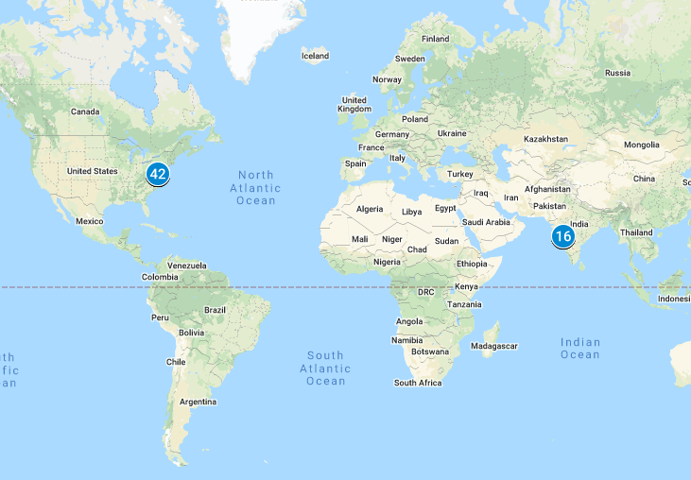

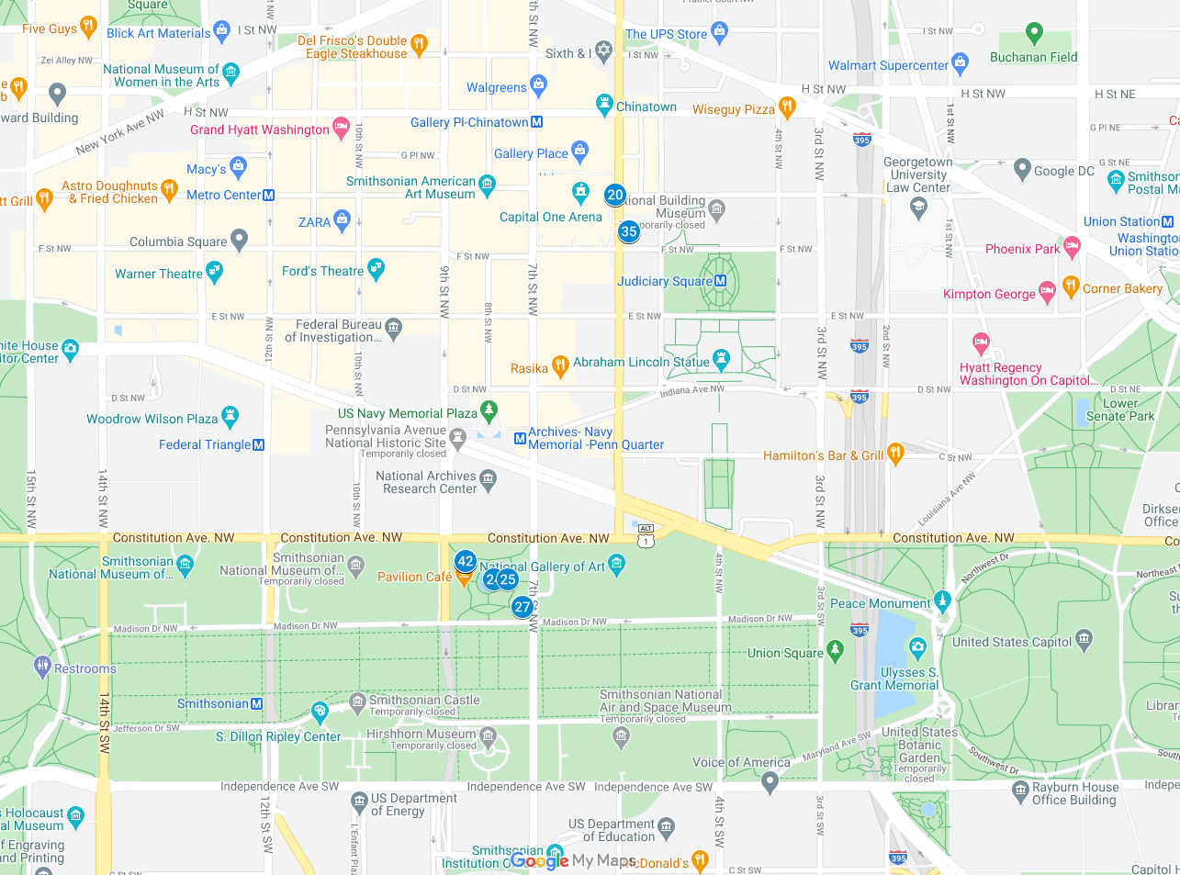

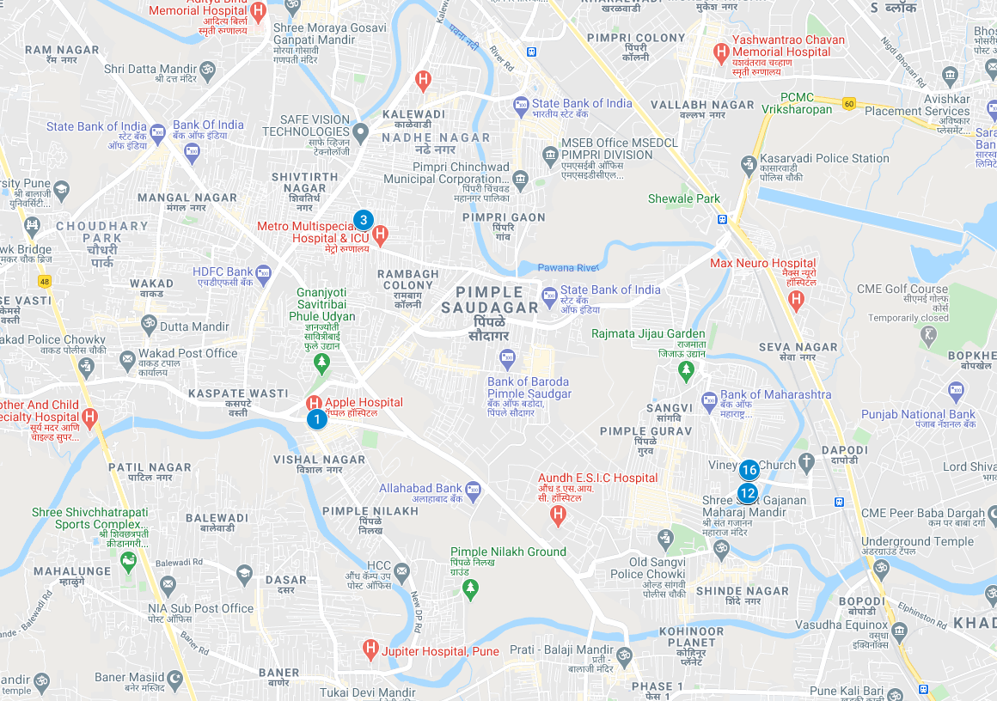

|  |  |  |  |  |
| --- | --- | --- | --- | --- |
| Location Information | | | | |
| Artifact | Timestamp | Header Information | Body | Screenshot |
| 1 | 2011:06:02 20:30:36 | 103725-f0134616.jpg | 20.9971666666666, 75.5613333333333 | <http://maps.google.com/maps?q=20.997166666666665,75.5613333333333> |
| 2 | 2011:05:29 23:00:53 | 103759-f0136568.jpg | 18.5886666666666, 73.7806666666666 | <http://maps.google.com/maps?q=18.58866666666667,73.7806666666666> |
| 3 | 2011:06:16 17:59:14 | 103776-f0138432.jpg | 18.6075, 73.7853333333333 | <http://maps.google.com/maps?q=18.6075,73.7853333333333> |
| 4 | 2011:06:16 17:59:21 | 103781-f0139800.jpg | 18.6075, 73.7853333333333 | <http://maps.google.com/maps?q=18.6075,73.7853333333333> |
| 5 | 2011:06:29 15:33:30 | 104496-f0039960.jpg | 18.5816666666666, 73.8236666666666 | <http://maps.google.com/maps?q=18.581666666666667,73.8236666666666> |
| 6 | 2011:06:29 15:33:41 | 106347-f0075728.jpg | 18.5816666666666, 73.8236666666666 | <http://maps.google.com/maps?q=18.581666666666667,73.8236666666666> |
| 7 | 2011:06:29 15:34:35 | 106388-f0077128.jpg | 18.5816666666666, 73.8236666666666 | <http://maps.google.com/maps?q=18.581666666666667,73.8236666666666> |
| 8 | 2011:06:29 15:34:39 | 106441-f0078648.jpg | 18.5816666666666, 73.8236666666666 | <http://maps.google.com/maps?q=18.581666666666667,73.8236666666666> |
| 9 | 2011:06:29 15:35:38 | 107430-f0100064.jpg | 18.5816666666666, 73.8236666666666 | <http://maps.google.com/maps?q=18.581666666666667,73.8236666666666> |
| 10 | 2011:06:29 15:35:46 | 107437-f0101112.jpg | 18.5816666666666, 73.8236666666666 | <http://maps.google.com/maps?q=18.581666666666667,73.8236666666666> |
| 11 | 2011:06:29 15:35:56 | 107441-f0102096.jpg | 18.5816666666666, 73.8236666666666 | <http://maps.google.com/maps?q=18.581666666666667,73.8236666666666> |
| 12 | 2011:06:29 15:36:34 | 107456-f0104072.jpg | 18.5816666666666, 73.8236666666666 | <http://maps.google.com/maps?q=18.581666666666667,73.8236666666666> |
| 13 | 2011:06:29 15:36:38 | 107459-f0105320.jpg | 18.5816666666666, 73.8236666666666 | <http://maps.google.com/maps?q=18.581666666666667,73.8236666666666> |
| 14 | 2011:05:04 12:47:53 | 108868-f0174160.jpg | 18.5838333333333, 73.8238333333333 | [http://maps.google.com/maps?q=18.583833333333335,73.8238333333333](http://maps.google.com/maps?q=18.581666666666667,73.8236666666666) |
| 15 | 2011:05:04 12:47:56 | 108872-f0175560.jpg | 18.5838333333333, 73.8238333333333 | [http://maps.google.com/maps?q=18.583833333333335,73.8238333333333](http://maps.google.com/maps?q=18.581666666666667,73.8236666666666) |
| 16 | 2011:05:10 08:51:18 | 111411-f0379216.jpg | 18.5838333333333, 73.8238333333333 | [http://maps.google.com/maps?q=18.583833333333335,73.8238333333333](http://maps.google.com/maps?q=18.581666666666667,73.8236666666666) |
| 17 | 2011:05:10 08:51:21 | 111440-f0382392.jpg | 18.5838333333333, 73.8238333333333 | [http://maps.google.com/maps?q=18.583833333333335,73.8238333333333](http://maps.google.com/maps?q=18.581666666666667,73.8236666666666) |
| 18 | 2012:06:23 14:44:22 | 113475-f0457256.jpg | 38.8983333333333, -77.02 | [http://maps.google.com/maps?q=38.89833333333333,-77.02](http://maps.google.com/maps?q=18.581666666666667,73.8236666666666) |
| 19 | 2012:06:23 14:44:37 | 113480-f0458800.jpg | 38.8983333333333, -77.02 | [http://maps.google.com/maps?q=38.89833333333333,-77.02](http://maps.google.com/maps?q=18.581666666666667,73.8236666666666) |
| 20 | 2012:06:23 14:44:41 | 113483-f0459744.jpg | 38.8983333333333, -77.02 | [http://maps.google.com/maps?q=38.89833333333333,-77.02](http://maps.google.com/maps?q=18.581666666666667,73.8236666666666) |
| 21 | 2012:06:23 14:44:53 | 113487-f0460648.jpg | 38.8983333333333, -77.02 | [http://maps.google.com/maps?q=38.89833333333333,-77.02](http://maps.google.com/maps?q=18.581666666666667,73.8236666666666) |
| 22 | 2012:07:08 12:33:36 | 43377-IMG_0042.JPG | 38.8916666666666, -77.0235 | [http://maps.google.com/maps?q=38.891666666666666,-77.0235](http://maps.google.com/maps?q=18.581666666666667,73.8236666666666) |
| 23 | 2012:07:08 12:34:31 | 43379-IMG_0043.JPG | 38.8916666666666, -77.0235 | [http://maps.google.com/maps?q=38.891666666666666,-77.0235](http://maps.google.com/maps?q=18.581666666666667,73.8236666666666) |
| 24 | 2012:07:08 12:34:50 | 43381-IMG_0044.JPG | 38.8916666666666, -77.0235 | [http://maps.google.com/maps?q=38.891666666666666,-77.0235](http://maps.google.com/maps?q=18.581666666666667,73.8236666666666) |
| 25 | 2012:07:08 12:35:50 | 43383-IMG_0045.JPG | 38.8913333333333, -77.0228333333333 | [http://maps.google.com/maps?q=38.891333333333336,-77.0228333333333](http://maps.google.com/maps?q=18.581666666666667,73.8236666666666) |
| 26 | 2012:07:08 12:36:30 | 43385-IMG_0046.JPG | 38.8913333333333, -77.0225 | [http://maps.google.com/maps?q=38.891333333333336,-77.0225](http://maps.google.com/maps?q=18.581666666666667,73.8236666666666) |
| 27 | 2012:07:08 12:37:16 | 43387-IMG_0047.JPG | 38.8908333333333, -77.0221666666666 | [http://maps.google.com/maps?q=38.89083333333333,-77.0221666666666](http://maps.google.com/maps?q=18.581666666666667,73.8236666666666) |
| 28 | 2012:07:08 12:37:37 | 43389-IMG_0048.JPG | 38.8908333333333, -77.0221666666666 | [http://maps.google.com/maps?q=38.89083333333333,-77.0221666666666](http://maps.google.com/maps?q=18.581666666666667,73.8236666666666) |
| 29 | 2012:07:08 12:41:41 | 43391-IMG_0049.JPG | 38.8916666666666, -77.0235 | [http://maps.google.com/maps?q=38.891666666666666,-77.0235](http://maps.google.com/maps?q=18.581666666666667,73.8236666666666) |
| 30 | 2012:07:08 12:41:53 | 43393-IMG_0050.JPG | 38.8916666666666, -77.0235 | [http://maps.google.com/maps?q=38.891666666666666,-77.0235](http://maps.google.com/maps?q=18.581666666666667,73.8236666666666) |
| 31 | 2012:07:08 12:42:03 | 43395-IMG_0051.JPG | 38.8916666666666, -77.0235 | [http://maps.google.com/maps?q=38.891666666666666,-77.0235](http://maps.google.com/maps?q=18.581666666666667,73.8236666666666) |
| 32 | 2012:07:08 12:49:25 | 43401-IMG_0054.JPG | 38.8976666666666, -77.0196666666666 | [http://maps.google.com/maps?q=38.897666666666666,-77.0196666666666](http://maps.google.com/maps?q=18.581666666666667,73.8236666666666) |
| 33 | 2012:07:08 12:49:37 | 43403-IMG_0055.JPG | 38.8976666666666, -77.0196666666666 | [http://maps.google.com/maps?q=38.897666666666666,-77.0196666666666](http://maps.google.com/maps?q=18.581666666666667,73.8236666666666) |
| 34 | 2012:07:08 12:49:49 | 43405-IMG_0056.JPG | 38.8976666666666, -77.0196666666666 | [http://maps.google.com/maps?q=38.897666666666666,-77.0196666666666](http://maps.google.com/maps?q=18.581666666666667,73.8236666666666) |
| 35 | 2012:07:08 12:50:07 | 43407-IMG_0057.JPG | 38.8976666666666, -77.0196666666666 | [http://maps.google.com/maps?q=38.897666666666666,-77.0196666666666](http://maps.google.com/maps?q=18.581666666666667,73.8236666666666) |
| 36 | 2012:07:08 12:50:20 | 43409-IMG_0058.JPG | 38.8976666666666, -77.0196666666666 | [http://maps.google.com/maps?q=38.897666666666666,-77.0196666666666](http://maps.google.com/maps?q=18.581666666666667,73.8236666666666) |
| 37 | 2012:07:08 12:51:44 | 43421-IMG_0064.JPG | 38.9085, -77.0181666666666 | [http://maps.google.com/maps?q=38.9085,-77.0181666666666](http://maps.google.com/maps?q=18.581666666666667,73.8236666666666) |
| 38 | 2012:07:08 12:59:55 | 43423-IMG_0065.JPG | 38.8916666666666, -77.0235 | [http://maps.google.com/maps?q=38.891666666666666,-77.0235](http://maps.google.com/maps?q=18.581666666666667,73.8236666666666) |
| 39 | 2012:07:08 13:00:01 | 43425-IMG_0066.JPG | 38.8916666666666, -77.0235 | [http://maps.google.com/maps?q=38.891666666666666,-77.0235](http://maps.google.com/maps?q=18.581666666666667,73.8236666666666) |
| 40 | 2012:07:08 13:00:07 | 43427-IMG_0067.JPG | 38.8916666666666, -77.0235 | [http://maps.google.com/maps?q=38.891666666666666,-77.0235](http://maps.google.com/maps?q=18.581666666666667,73.8236666666666) |
| 41 | 2012:07:08 13:00:12 | 43429-IMG_0068.JPG | 38.8916666666666, -77.0235 | [http://maps.google.com/maps?q=38.891666666666666,-77.0235](http://maps.google.com/maps?q=18.581666666666667,73.8236666666666) |
| 42 | 2012:07:08 13:00:23 | 43431-IMG_0069.JPG | 38.8916666666666, -77.0235 | [http://maps.google.com/maps?q=38.891666666666666,-77.0235](http://maps.google.com/maps?q=18.581666666666667,73.8236666666666) |
| 43 | 2012:07:08 13:02:23 | 43433-IMG_0070.JPG | 38.8916666666666, -77.0235 | [http://maps.google.com/maps?q=38.891666666666666,-77.0235](http://maps.google.com/maps?q=18.581666666666667,73.8236666666666) |

### 